Field Bulletin

Impact of Microsoft Internet Explorer ActiveX update

Product Affected: IDM Web Services and Open Client

Introduction
Due to a lost of a lawsuit, Microsoft has began changing the behavior of Internet Explorer in a Microsoft Internet Explorer ActiveX update to avoid infringing a patent or license fees. Users who receive this IE update will no longer be able to directly interact with Microsoft ActiveX controls and applets loaded by the APPLET, EMBED, or OBJECT elements/tags. The changes mean that they might need to perform an additional mouse click (or use the TAB key to set focus on the control and then press the SPACEBAR or the ENTER key) to interact with ActiveX controls and applets that are loaded in a Web page using traditional methods (i.e., loaded by APPLET, EMBED, or OBJECT elements/tags).

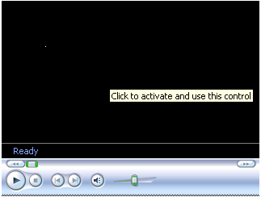
Impact of the IE update
Figure 1. Impact of new patch on ActiveX controls and Applets
This patch will affect IE on Windows Server 2003, Windows XP, and Windows 2000. These changes will be done via Windows Update and other Microsoft software updating tools. Upcoming products, such as Windows Vista and IE 7, will also include the changes.

Impact on users
The following are some of the impacts on end users who receive this Microsoft Internet Explorer ActiveX update:

- The user must consent to activating an object each time a page embeds an object for which the designer has not coded a workaround.
- If the user chooses not to give consent to activate objects, many pages will break.
- If the user chooses to disable embedded objects, many pages will break.
- If the user chooses to disable JavaScript or JScript, many pages will break.

Impact on IDM Web Services and Open Client

Impact on IDM Web Services

IDM Web Services code uses all the three APPLET, EMBED, and OBJECT tags. An APPLET tag is primarily used in remote scripting related script files like FNRS.htm, FNRS2.htm and RS.htm. However, the applet tag in these pages will not have any effect on our existing functionality as these are used in non-interactive way. The other two tags (i.e., OBJECT and EMBED) are used heavily in IDM Web Services pages. To implement the workaround solution we have to do recoding in majority of the IDM Web Services pages. The eProcess pages of the IDMWS will also be affected by the new patch.

The following figure shows the behavior of ActiveX controls on IDM Web Services pages after applying the Microsoft Internet Explorer ActiveX update:

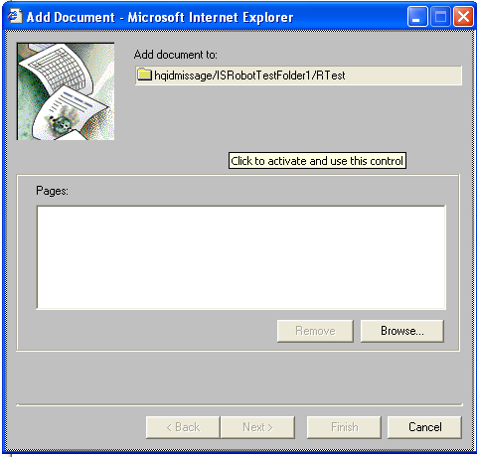
Impact of the IE update

Figure 2: Impact on IDM Web Services

Impact on Open Client

Open Client code uses APPLET, EMBED, or OBJECT tags in two cases:

Java Viewer Applet: APPLET tag is used to load Java Viewer applet and thus with the Microsoft Internet Explorer ActiveX update, the end-user has to click on the Java viewer applet to activate its user interface. This behavior is shown in the following figure:

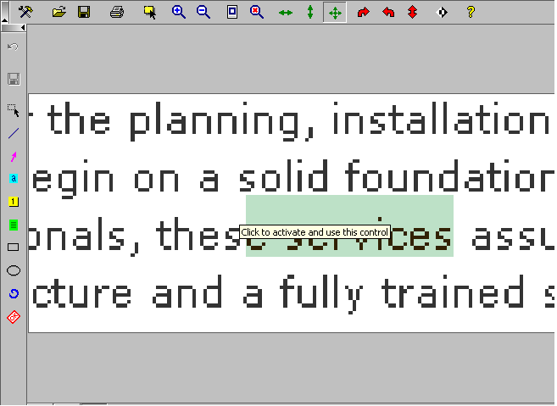
Impact of the IE update

Figure 3: Impact on Java Viewer in Open Client

eProcess applets: eProcess applets use APPLET, OBJECT, EMBED tags. Only OBJECT tag is used in case of IE browser. The following figure shows the impact of the Micrsoft Internet Explorer ActiveX update on eProcess designer window.

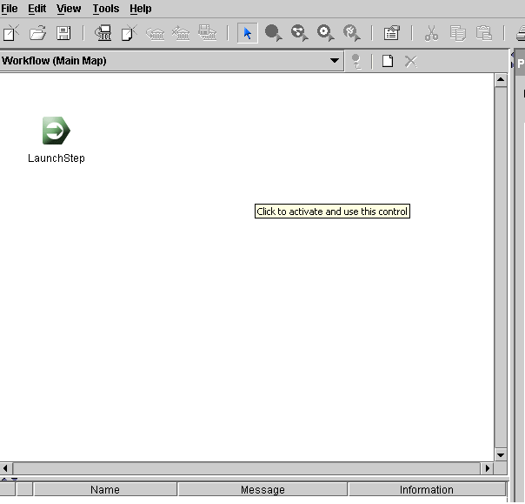
Impact of the IE update

Figure 4: Impact on eProcess applets in Open Client

Possible solution
As stated above, the Microsoft Internet Explorer ActiveX update update will affect any ActiveX control loaded using an <OBJECT>, <APPLET>, or <EMBED> tag within a page. ActiveX objects loaded by a page will not be interactive unless the user clicks on them. In other words, when users hover the mouse over an inactive object, they'll see a message telling them to click to activate the object. When the user clicks on the control it will get activated.

The workaround solution that will not require the user to click on the loaded object. However, this solution requires changes in the code. The workaround solution involves loading ActiveX objects via an included external script (JScript/JavaScript or VBScript) file.

Sample Workaround solution
Current HTML file

<html>
<body>
<OBJECT id='appletPlugIn' classid='clsid:8AD9C840-044E-11D1-B3E9-00805F499D93' width='100%' height='100%'
codebase='http://localhost/FNOpenClient/eProcess/download/j2re-1_4_2-windows-i586.exe'>
<PARAM NAME='java_code' VALUE='filenet.vw.apps.designer.VWDesignerApplet'>
<PARAM NAME='java_codebase' VALUE='http://localhost/FNOpenClient/eProcess/download/ '>
<PARAM NAME='java_type' VALUE='application/x-java-applet;version=1.4.2'>
--------------------------------------------------------------
---------------------------------------------------------------
<PARAM NAME='cache_option' VALUE='Plugin'>
</OBJECT>
</body>
</html>

In the new scenario following code snippet can be used to load an ActiveX control instead of currently followed way:

Modified HTML file

<html>
<body>
<script src="Object.js"></script>
</body>
</html>

External script file ➔Object.js

document.write('<OBJECT id=“appletPlugIn” classid=”clsid:8AD9C840-044E-11D1-B3E9-00805F499D93” width=“100%” height=“100%”
codebase=“http://localhost/FNOpenClient/eProcess/download/j2re-1_4_2-windows-i586.exe”>
<PARAM NAME=“java_code” VALUE=“filenet.vw.apps.designer.VWDesignerApplet”>
<PARAM NAME=“java_codebase” VALUE=“http://localhost/FNOpenClient/eProcess/download/”>
<PARAM NAME=“java_type” VALUE=“application/x-java-applet;version=1.4.2”>
--------------------------------------------------------------
--------------------------------------------------------------
---------------------------------------------------------------
<PARAM NAME=“cache_option” VALUE=“Plugin”>
</OBJECT>');

Resolutions
- The Microsoft Internet Explorer ActiveX update is already avaiable as of February 28th, 2006. FileNet recommends it’s customers NOT to apply this update until FileNet has the solution implemented and release in a patch for IDM Web Services and Open Client.
- The Microsoft monthly security update, which will contain the IE update, is scheduled for April 11th, 2006. It’s unclear at this point if it’s possible to uninstall this IE update once the security update is applied. FileNet recommends it’s customers NOT to apply this update until FileNet has the solution implemented and release in a patch for IDM Web Services and Open Client.
- IDM patches
IDM v3.3 Patch 20 - Late May
IDM v3.3 Patch 21 - Mid June (NOTE: This patch will contain the ActiveX changes)
IDM v4.0 Patch 08 - Early May
IDM v4.0 Patch 09 - Early June (NOTE: This patch will contain the ActiveX changes)

- Open Client patches
OC v3.3 Patch 16 - Early May (NOTE: This patch will contain the ActiveX changes)
OC v3.3 Patch 17 - Early July
OC v4.0 Patch 05 - Already released (NOTE: This patch will contain the ActiveX changes)
OC v4.0 Patch 06 - Early June

References
- In the Eolas Patent Lawsuit, Users Lose
- Activating ActiveX Controls
- Browser News: Browsers & US Patent 5,838,906
- To Sidestep Eolas Patent, Microsoft Plots IE Changes

