Repository Migration
PASW Collaboration and Deployment Services 4

Contents
Migration Scenarios 3
Repository Migration Paths 3
Saving and Restoring the Repository 3
Saving the Repository 4
Restoring the Repository 7
Rerunning Setup 9
Overwriting an Existing SPSS Predictive Enterprise Services Installation 10
Repository Migration with Schema Copy Utility 10
SWDF Content Migration 11
ShowCase Content Migration 11

Migration Scenarios
The following migration scenarios are supported for PASW Collaboration and Deployment Services 4:
- Repository migration from SPSS Predictive Enterprise Services 3.0
- Repository migration from SPSS Predictive Enterprise Services 3.5
- Migration of SPSS Web Deployment Framework objects.
- Migration of ShowCase objects.
Important! For SPSS Predictive Enterprise Services IBM i installations with a large number of objects, it is recommended that the number of migrated objects not exceed 6,000 files and 10,000 relationships.

Repository Migration Paths
The following paths can be used for migrating to PASW Collaboration and Deployment services 4 from an earlier version of the system.
- Saving and restoring the repository. In most environments, saving and restoring the repository is recommended.
- “Over-the-top” installation. Installation of PASW Collaboration and Deployment Services 4 with an existing repository database is generally more resource-intensive because additional backups of the operational environment may be required.
- Migration using the database copy utility. Using the database copy utility is recommended only when migration of SPSS Predictive Enterprise Services 3.0 repository on IBM i to PASW Collaboration and Deployment Services 4 cannot be completed due to memory errors.
Important! Regardless of the selected migration path, it is recommended that the latest patches be applied to the existing SPSS Predictive Enterprise Services installation before migration is performed. To obtain the patches, contact SPSS product support.

Saving and Restoring the Repository
Save and Restore Utility can be used to preserve the configuration and the contents of the existing SPSS Predictive Enterprise Services 3.0 and 3.5 and PASW Collaboration and Deployment Services 4 repository including the following:
- Content repository files and folder structure
- Scheduling and notification components
- Local users
- Locally defined overrides of remote directory user lists and groups
- Role definitions and membership
- User preferences
- Notification templates
- Icons
- Deployed packages

Important! Save and restore utility preserves the package configuration, but PASW Collaboration and Deployment Services may require updated versions of packages, for example, you may need to replace Clementine 12 adaptor with Modeler 13 adaptor.

The repository is saved in a compressed archive file which can later be used to restore the content a configuration settings.

The following table presents the use cases for Save and Restore Utility.

Source | Target
Source | SPSS Predictive Enterprise Services 3.0 | SPSS Predictive Enterprise Services 3.5 | PASW Collaboration and Deployment Services 4
SPSS Predictive Enterprise Services 3.0 | ✓* | ✓* | ✓*
SPSS Predictive Enterprise Services 3.5 |  | ✓ | ✓
PASW Collaboration and Deployment Services 4 |  |  | ✓
* It may be necessary to use database copy utility instead of the save/restore utility because of out of memory Java exceptions.
When Save and Restore Utility is used as a migration tool, the following prerequisites must be in place before migration is performed:
- Existing SPSS Predictive Enterprise Repository database must be backed up.
- PASW Collaboration and Deployment Services 4.0 must be installed and licensed. For more information, refer to PASW Collaboration and Deployment Services 4 Installation and Configuration Guide.
The following steps must be completed for a successful migration:
- Saving the existing SPSS Predictive Enterprise Repository.
- Restoring saved data to PASW Collaboration and Deployment Services 4.0 repository.
- Rerunning setup tool to update system configuration values.
- Reinstalling packages.

Saving the Repository
The SPSS Save Tool can be used as a GUI application or as a command line utility. It can also be called in batch mode by other applications. The user must be assigned the Administrator role in SPSS Predictive Enterprise Services to perform the save operation. It is strongly recommended to stop SPSS Predictive Enterprise Services before saving.
To save a repository with the GUI application:
- Navigate to <SPSS Predictive Enterprise Services Installation Directory>/setup/.
- Depending on the operating system, execute save.bat on Windows or save.sh on UNIX and IBM i.
- When prompted, enter the username and password.
Figure 1. Local Administrator Logon dialog box for the Save Tool
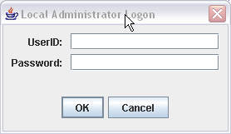
- Click OK to log in. The SPSS Save Tool dialog box opens.
Figure 2. Save Tool dialog box
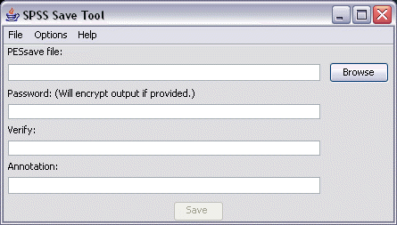
- Select the save format.
- To save the data as a compressed archive, from the menus choose:
Options
Single .PESsave
- To save the data as a collection of files, from the menus choose:
Options
Directory with Files
- Enter the file/directory path or click Browse to navigate to the location where the data will be saved.
Note: If the archive file has been selected as the save option, the .PESsave extension will be automatically appended to the specified filename. If the directory has been selected as the save option, the target directory cannot already contain SPSS Predictive Enterprise Services save data.
- To encrypt the data, enter and verify the password. Any alphanumeric string can be used as the password.
- Add the annotation to the saved data if necessary. An annotation is a descriptive string that will be displayed when the data source (archive file or directory) is selected for system restore.
- Click Save. The status panel appears.
Figure 3. Save operation progress
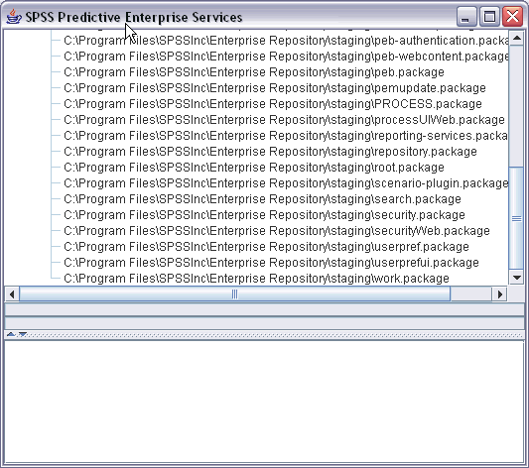
If errors occur during the save operation, they are displayed in red in the bottom pane. The installation log can be found in <SPSS Predictive Enterprise Services Installation Directory>/setup/logs/saverestore.log. At the end of the operation, a message specifying duration is also displayed.
- Close the status panel. This will also close the SPSS Save Tool.
To save a repository using the command line utility:
- Navigate to <SPSS Predictive Enterprise Services Installation Directory>/setup/.
- Execute the saverestore -headless command with the following required arguments:
-userid <user ID> The user under whose credential the save operation is being performed.
-userpassword <password> The password of the user.
-save <data location path> The path of the saved data.
Optional arguments include:
-explode The option to save the data as a directory.
-filepassword <file password> Encryption password.
-annotation <annotation> The annotation string. If the annotation contains spaces, it must be enclosed in quotation marks.
-lang <language code> The language code for localized instances of PASW Collaboration and Deployment Services.
The following examples illustrate saving the contents of the repository in a password-protected file with an annotation.
Windows:
saverestore -headless -userid admin -userpassword pass1234 -save c:/temp/saveFile -filepassword secret -annotation "Preparing data for migration 1/09/2009"
IBM i:
./saverestore.qsh -headless -userid admin -userpassword pass1234 -save /home/paswuser/savefile -filepassword secret -annotation "Preparing data for migration 1/09/2009"
UNIX:
./saverestore.sh -headless -userid admin -userpassword pass1234 -save /home/paswuser/saveFile -filepassword secret -annotation "Preparing data for migration 1/09/2009"

Restoring the Repository
Similarly to SPSS Save Tool, SPSS Restore Tool can also be used as a GUI application or as a command line utility. It can be called in batch mode by other applications as well. The user must be assigned the Administrator role in PASW Collaboration and Deployment Services to perform the save operation. If PASW Collaboration and Deployment Services are being restored over an existing instance, the existing content will be overwritten. In such cases, it is strongly recommended to stop PASW Collaboration and Deployment Services before restoring. If PASW Collaboration and Deployment Services are being migrated to another server, application components must already be in place on the new host. Therefore, the installation must be run prior to restoring.
To restore a repository with the GUI application:
- Navigate to <PASW Collaboration and Deployment Services Installation Directory>/setup/.
- Depending on the operating system, execute restore.bat on Windows or restore.sh on UNIX or IBM i.
- When prompted, enter the username and password.
- Click OK to log in. The SPSS Restore Tool dialog box opens.
Figure 4. Restore Tool dialog box
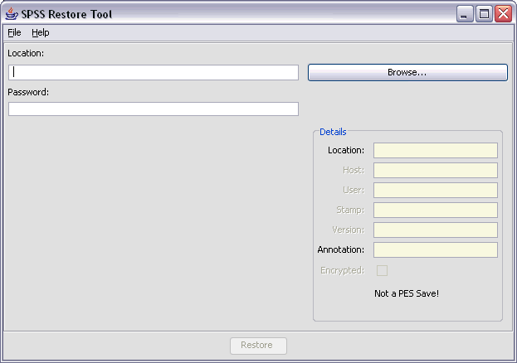
- Enter the file/directory path or click the Browse button to navigate to the location where the data were previously saved. After the data source has been selected, the corresponding information is displayed in the Details group box.
Note: If the restore utility is run, the specified data source path is retained and will be displayed by default the next time the restore utility is opened.
- If the data have been encrypted, enter the password. The field is unavailable for unencrypted files.
- Click Restore. The status panel appears. If errors occur during the restore operation, they are displayed in red in the bottom pane. The installation log can be found in <PASW Collaboration and Deployment Services Installation Directory>/setup/logs/saverestore.log. At the end of the operation, a message specifying duration is also displayed.
- Close the status panel. This will also close the SPSS Restore Tool.
To restore a repository using the command line utility:
- Navigate to <PASW Collaboration and Deployment Services Installation Directory>/setup/.
- Execute the saverestore -headless command with the following required arguments:
-userid <user ID>. The user under whose credential the restore operation is being performed.
-userpassword <password>. The password of the user.
-restore <data location path> The path of the restored data.
Optional arguments include:
-filepassword <file password> For encrypted files, the password.
-setupdir <path> Option to indicate that the setup directory is different from the current directory.
The following example illustrates restoring the contents of the repository from a password-protected file.
Windows:
saverestore -headless -userid admin -userpassword pass1234 -restore c:/paswuser/saveFile -filepassword secret
IBM i:
./saverestore.qsh -headless -userid admin -userpassword pass1234 -restore /home/paswuser/savefile -filepassword secret
UNIX:
./saverestore.sh -headless -userid admin -userpassword pass1234 -restore /home/paswuser/saveFile -filepassword secret

Rerunning Setup
After a repository from an earlier version of the system has been migrated to PASW Collaboration and Deployment Services 4, system configuration values in repository must be reset by rerunning setup utility. The utility is initially run as part of PASW Collaboration and Deployment Services 4 installation.
To rerun setup:
- Start setup utility.
Windows:
<PASW CADS 4 installation directory>/setup/setup.bat
Unix:
<PASW CADS 4 installation directory>/setup/setup.sh
IBM i:
<PASW CADS 4 installation directory>/setup/clisetup.qsh
- Specify setup parameters as prompted by the wizard or command line. The parameters include keystore location, application server, database, administrator password, and email settings for notifications. For detailed information on setup parameters, see “Installing the Repository” section of the PASW Collaboration and Deployment Services 4 Installation and Configuration Guide.

Overwriting an Existing SPSS Predictive Enterprise Services Installation
You can also upgrade to PASW Collaboration and Deployment Services 4 by installing the system over an older version. In that case, during the setup you must point to the existing repository database. For more information, see “Upgrading the Repository” and “Installing the Repository” sections of PASW Collaboration and Deployment Services 4 Installation and Configuration Guide.
Important! Full database backup is strongly recommended prior to over-the-top installation because it is impossible to revert to the old version of the repository once PASW Collaboration and Deployment Services 4 have been installed.

Repository Migration with Schema Copy Utility
Database schema copy utility is intended for migrating SPSS Predictive Enterprise 3.0 to a PASW Collaboration and Deployment Services 4 on IBM i when it cannot be accomplished through the Save and Restore Utility due to Java memory exceptions. Under this scenario, a copy of the repository database is created and subsequently PASW Collaboration and Deployment Services 4 installed.
The schema copy utility is provided on PASW Collaboration and Deployment Services 4 distribution disk in /PASW/IBMi/CopySchemaUtil.jar.
To run the schema copy utility:
- Copy the CopySchemaUtil.jar to Java class path location on the IFS.
- Execute the schema copy utility in IBM i QShell. The command is as follow:

java -Djava.version=1.5 -cp /<classpath_dir>/CopySchemaUtil.jar:/QIBM/ProdData/HTTP/Public/jt400/lib/jt400.jar
com.spss.util.schema.DuplicateIBMiSchema
-systemName <host_name> -user <user> -password <password>
-sourceSchema <source_schema>
-targetSchema <target_schema>
[-replaceTargetSchema] [-debug]

In the following example, the utility is run to copy schema PES3.5 to PASWCADS4 on host PASWCADSI5 under the database credentials of DBUSER with password DBPWD. The target schema is removed prior to copying (–replaceTargetSchem option) and extra output is logged for troubleshooting purposes (-debug option).

java -Djava.version=1.5 -cp /PASWUser/DBCopy/CopySchemaUtil.jar:/QIBM/ProdData/HTTP/Public/jt400/lib/jt400.jar com.spss.util.schema.DuplicateIBMiSchema -systemName PASWCADSI5 -user DBUSER -password DBPWD -sourceSchema PES3.5 -targetSchema PASWCADS4 –replaceTargetSchema –debug

After the database has been copied, you must install PASW Collaboration and Deployment Services 4, pointing it to the copy of the repository database. For more information about the installation, see “Installing the Repository” sections of PASW Collaboration and Deployment Services 4 Installation and Configuration Guide.

SWDF Content Migration
PASW Collaboration and Deployment Services 4 provides for migration of legacy SPSS Web Deployment Framework content, such as SmartViewer Web Server and Cleo objects and metadata.
Important! Migration of custom interfaces is not supported.
To migrate SWDF content:
- Create the export file using SPSS Web Deployment Framework Offline Administrator 2.7.
- Run the SWDF migration utility. For more information about the utility, see the appendix to PASW Collaboration and Deployment Services 4 Installation and Configuration Guide.

ShowCase Content Migration
For information about ShowCase content migration, refer to ShowCase Suite Upgrade Guide.

