Upgrading to ShowCase Analyzer 6.21
ShowCase Analyzer 6.21 is a major new release of the Analyzer product. This new release includes many new features that make it easier than ever to create and deliver valuable business insight to the people that need it most.

In order to deliver enhanced functionality to all users, the product has been built on a new Java based architecture. This architecture allows users to access all of the powerful analytic functions that Analyzer provides from within their Web browser.

With any change of this magnitude, the process for upgrading to the new release includes a migration phase that must be carefully planned and implemented. The STRATEGY Analyzer 6.21 Guide provides detailed instructions on how to migrate from STRATEGY 4.x and how to get started with the new Analyzer 6.21 product. Please make sure to carefully read the STRATEGY Analyzer 6.21 Guide carefully before planning for your upgrade.

This document provides an overview of the new Analyzer architecture and some additional considerations that should help to make the transition to the new release as smooth as possible.

Table of Contents
ShowCase Analyzer 6.21 Architecture 1
Performance Considerations 1
ShowCase Analyzer 6.21 Components 2
ShowCase Analyzer 6.21 Architectural Overview 2
Architecture Comparison to STRATEGY 4.5 Analyzer 3
Migrating to Analyzer 6.21 3
Migration Preparation 4
Migration Tips 4
Using DMPAOS and the MIGRATE table 5
Known Migration Issues 9
Troubleshooting 9
SUPPORT 9

ShowCase Analyzer 6.21 Architecture
As mentioned above, the Analyzer 6.21 architecture is quite different from previous releases. When upgrading to this release from STRATEGY 4.5, it is important that you understand this new architecture and the impacts that it will have on your end user’s performance. The following sections describe the new architecture and compare it to the STRATEGY 4.5 architecture.

Performance Considerations
Because of the change in where the processing is being done, the performance of the Java based applications is going to be more dependent on the computing power that is on the server that the Application Server is running on and less dependent on the client workstations. Performance will also be more impacted when users are accessing the same server resources at the same time.

When moving to the Java based architecture, server capacity needs to be considered. With some older server hardware, this can be a major issue because Java does not perform well on these machines. Please refer to the STRATEGY 6.5 Enterprise Reporting Performance Guidelines which discusses performance considerations when running Java applications on the iSeries. This information is also applicable to the Analyzer 6.21 Server on the iSeries.

ShowCase Analyzer 6.21 Components
ShowCase Analyzer 6.21 consists of the following components:
- Java Web Client – the Analyzer Java Web client enables online analysis of data. It allows users to view and interact with pre-defined reports. Using the Java Web Client, report designers can design and format custom analysis applications without “coding”. The Java Web Client is an applet based application that runs within your Web Browser.
- Administration Tool – the Analyzer Administration tool is a client that provides a Java graphical user interface for managing users, users groups, report groups and security, and database connections using a Web browser.
- Analysis Server – The Analyzer Analysis server is a servlet based Web application that resides within the integrated J2EE application server (ORION) on your iSeries server. The server facilitates the rendering of reports for the Java Web clients and provides the services for the Analyzer Administration tool.
- Repository – the Analyzer repository is a central storage location for Analyzer system data, user ids, user preferences and report definitions. The repository is stored in tables in the Analyzer server library.
- API Toolkit – the Analyzer API Toolkit is a tool that helps developers incorporate the Analyzer Java Web client look and feel and functionality into their own custom Web applications.

ShowCase Analyzer 6.21 Architectural Overview
The ShowCase Analyzer functionality is distributed across a multi-tiered architecture:
- Client layer
- Mid-tier layer
- Database server layer

The client layer includes the Java Web Client and the Administration Tools client, as well as the API Toolkit. All clients communicate with the rest of the Analyzer system using HTTP.

The mid-tier layer includes the following components:
- The Web Server
- The J2EE application server
- The Analyzer Analysis Server
- Drivers for communicating with the database server layer

The Web Server and J2EE application server components are integrated with the Analyzer Analysis Server so they are not separately installable and they are transparent to the users. During the installation process, the Analysis server is deployed into the J2EE application server and the Analyzer repository tables are created in the Analyzer server library.

All of the mid-tier components reside on the iSeries within the ShowCase Analyzer Server library.

The database server layer includes both the OLAP (Essbase) and relational databases that are used for analysis, and the relational Analyzer repository. The relational Analyzer repository is stored in the Analyzer Server library on the iSeries. The relational databases used for analysis must be DB2/400 databases and they are accessed via a JDBC driver. The OLAP (Essbase) databases can be located anywhere on the network and they are accessed using the Java Essbase API via an IP address.

Architecture Comparison to STRATEGY 4.5 Analyzer
In STRATEGY 4.5, there are two different client architectures – one for the Windows based applications and one for the Java based Analyzer for the Web. The Windows clients consist of the main Analyzer application and the Design Tools. Analyzer administration for STRATEGY 4.5 is performed within the Warehouse Manager Client application. The architecture for the Analyzer for the Web client is very similar to the new Analyzer 6.21 architecture, but the Windows clients are much different.

The Windows based applications contain all of the logic for handling key strokes and rendering the display images along with all of the database access logic. The performance of the Windows applications is mostly dependent on the computing power on the Windows desktop and the Windows applications require software installation and maintenance on each of the client workstations.

The Java based applications communicate with the Application server for much of the functional logic and for the database access logic. This allows more of the functionality to be centralized so that less is being done on the client layer and it provides an architecture that does not require any software installation or maintenance on the client machines.

Migrating to Analyzer 6.21

The STRATEGY Analyzer 6.21 Guide outlines the steps necessary to migrate from Analyzer 4.5's views and forms to Analyzer 6.21's reports. Please review Chapter 6, Analyzer Migration for complete instructions on how to achieve a successful migration. This article is intended to enhance the existing documentation and to provide some helpful hints.

Migration Preparation

Understand environment requirements
In the STRATEGY Analyzer 6.21 Guide, read Chapter 4, Environment Requirements.

Also review the following requirements:

For JDK 1.4 to work on your iSeries, you must install:
- V5R1M0 with PTF CUM package C2134510 or later.
- 5722JV1 Option *BASE with Java Group PTF 11 or later.

Some features won’t migrate
In the STRATEGY Analyzer 6.21 Guide, read Chapter 6, Analyzer Migration. This chapter describes which data will and won’t migrate, and what’s different after migration.

Apply the current Analyzer 6.21 patch
This will ensure your Analyzer code is up to date and help migration go as smoothly as possible. Several migration problems were fixed in early patches. You can find the patch at http://support.spss.com. After you log in, click Patches.

Log in to Analyzer at least once
Before starting migration, you must log into and out of the application at least once after applying the latest patch.

Migration Tips

When to migrate
Because the system is heavily taxed during migration, consider planning migration over a weekend.

How long it will take to migrate
Because the migration opens and runs migrating views, the time to migrate is unpredictable and could take several hours or longer than a day depending on:
- The number of views
- The size of views
- If the system is dedicated for migration
- The cleanliness of the repository (Objects that don’t work currently could take longer to migrate.)

Run the migration with SBMJOB, not interactively
When you run the DMPAOS or MIGAOS commands, use the SBMJOB (Submit Job) command instead of running interactively. Submitting the DMPAOS job frees the session during the migration, and generates QPJOBLOG in the issuer's spool files. Signing off the session will not lose this valuable information.

DMPAOS Example
At an iSeries command line, type SBMJOB and press F4 to prompt. On the “Command to run” line, type the following, substituting your data and desired values:

ANZSERVER/DMPAOS DEV(*SAVF) SAVF(TEST) ESSSRVMAP(*ALL) NEWESSSRV(ESSBASE)

For a description of the parameters (listed below), see the STRATEGY Analyzer 6.21 Guide, page 26. Note Figure 6-2.

ANZSERVER/DMPAOS
DEV(*SAVF)
SAVF(TEST)
ESSSRVMAP(*ALL)
NEWESSSRV(ESSBASE)

MIGAOS Example
At an iSeries command line, type SBMJOB and press F4 to prompt. On the “Command to run” line, type the following, substituting your data and desired values:

ANZSERVER/MIGAOS DEV(*SAVF) SAVF(TEST) USER(*REPLACE) DATABASE(*REPLACE) REPORT(*REPLACE) TABLE(*YES) INCLUDE(*YES)

For a description of the parameters (listed below), see the STRATEGY Analyzer 6.21 Guide, page 29. Note Figure 6-3.

ANZSERVER/MIGAOS
DEV(*SAVF)
SAVF(TEST)
USER(*REPLACE)
DATABASE(*REPLACE)
REPORT(*REPLACE)
TABLE(*YES)
INCLUDE(*YES)

Migrate everything
During Analyzer migration, we recommend migrating everything, including your databases. For example, on the MIGAOS command, specify *KEEP or *REPLACE when migrating databases. If the views have already been migrated, you can export and re-import the migrated views, or re-migrate the views to include the databases (using the *KEEP or *REPLACE options).
If databases are not migrated during migration, the migration creates personal databases, each requiring a separate login to open a migrated view, and you could receive multiple Essbase login prompts from Analyzer (even with “Analyzer & Essbase Security” enabled).

Resolution 36042

Using DMPAOS and the MIGRATE table
In the Analyzer upgrade process, SPSS added a great tool to review the results of the migration without upgrading the data. Using 4.x's SAVSRVRINF, the DMPAOS will allow you to preview the results before running the MIGAOS. These two processes allow customers to evaluate their data, before taking the final step. The DMPAOS generates a Migrate table in the ANZSERVER library providing line entry information for each object that will be migrated to Analyzer 6.21. Using the Migrate table and the QPJOBLOG, customer’s can determine why an item did not migrate and can use the Migrate table to facilitate cleanup of the data before migration.

DMPAOS Command
The DMPAOS and MIGAOS programs provide detail migration information in the joblog. In the joblog you can confirm the parameters entered for the migration and review how each piece was handled. If the DMPAOS or MIGAOS is run interactively, use the DSPJOBLOG OUTPUT(*PRINT) command to view this detail information. Note that if you do not use the *print parameter, when the user session is ended, the joblog is gone.
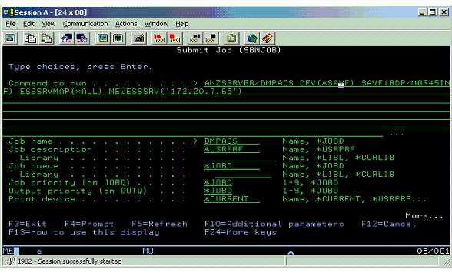
Figure 1 – Example of Submit Job command
The QPJOBLOG can be used to troubleshoot items that have a "WARNING" or "ERROR" status. All views and forms are noted in the log as well as migration of the groups, users, and databases. The following print screen displays a joblog view that will migrate but has a warning status.
Suggestion: On this "Display Spooled File" screen, entering the view name in the "FIND" parameter and using <F16> will provide a quick search through the log. Example: Ord - Division Form2
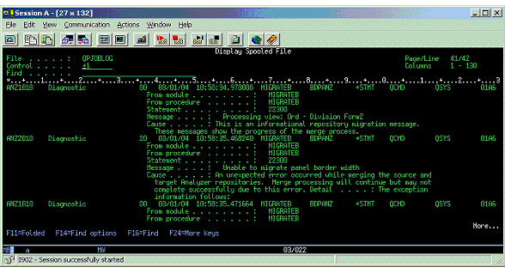

The Migrate table
The DMPAOS command uses the migration program to produce a Migrate table and generate a joblog without actually migrating views to the new environment. These tools allow you to review what will and will not migrate before officially migrating to the new environment. The Migrate table (file) will reside in the Analyzer 6.21 library. Note that the MIGAOS DOES NOT produce a Migrate table.
This table explains why an item did not migrate. So, if you run the migration (MIGAOS) first and have questions, run DMPAOS to produce the table. Be sure that the same SAVSRVINF file is used for both the MIGAOS and DMPAOS command.
The Migrate table will provide information on the following items along with its status:
TYPE | STATUS
1. Database  2. User  3. Group  4. Report | 1. Success  2. Warning  3. Error
Example:
TYPE | STATUS | REPORT | USR | GROUP | DATABASE | NOTES
DATABASE | SUCCESS |  |  |  | 172.20.7.90:bdp:Basic
DATABASE | SUCCESS |  |  |  | 172.207.980:xxxSwift:C216
DATABASE | SUCCESS |  |  |  | 172.20.7.90:LTLL:Ltlcontr
DATABASE | SUCCESS |  |  |  | 172.20.7.90:SALES:SALES
GROUP | SUCCESS |  | {System} |  | Swift
GROUP | SUCCESS |  | {System} |  | Performance
GROUP | SUCCESS |  | {System} |  | Panel
REPORT | SUCCESS | Order - Division | {System} | SWIFT | 172.20.7.90:xxxSwift:C216
REPORT | WARNING | Order - Division Form2 | {System} | SWIFT | 172.20.7.90:xxxSwift:C216 | Unable to migrate panel border width  Ú
REPORT | ERROR | LTL CONTRIUBTION | Pbrown | Panel | 172.20.7.90:LTLL:Ltlcontr | Unable to access database
REPORT | WARNING | Sales Form | Pbrown | Panel | 172.20.7.90:SALES:SALES | Unable to migrate label alignment  ÚTC_DesignerSpreadDisplay has been migrated to a label.  Ú
REPORT | WARNING | Mgr Form | Jdavis | Express | Express | Unable to migrate panel border width  ÚUnable to migrate panel border width  ÚUnable to migrate panel border width  ÚUnable to migrate panel border width  ÚUnable to migrate panel border width  ÚUnable to migrate panel border width  ÚUnable to migrate panel border width
REPORT | ERROR | Percent of Total | Jdavis | Express | Express | Unable to access database Avon
USER | SUCCESS |  | BBRYANT
USER | SUCCESS |  | BCECIL
USER | SUCCESS |  | BCOLEMAN
USER | SUCCESS |  | BDP
USER | SUCCESS |  | BISON

Suggestion: The easiest method to review and manipulate this table is by accessing the Migrate table (ANZSERVER/MIGRATE) with Query, selecting all the columns, running the query and then "Saving the Data As" an Excel file. The same result can be accomplished by changing the Result Options to an Excel Worksheet. This is the format that should be used when sending Migrate table to Support.
The Analyzer Migration chapter provides detail information about this table and how to modify it for cleansing the data.
Suggestion: Update the table and enter ERROR in the status column of the items that should not be migrated, and they will be skipped during the migration process. For example the USER column is populated by a table in the 4.5 SCServer library. If some users are no longer with the company, changing the status to ERROR, will keep them from migrating to 6.21.

Migrating using the MIGAOS Command and the Migrate Table
The MIGAOS parameter "Use DMPAOS results" allows the user to specify whether or not to use the Migrate table when migrating.
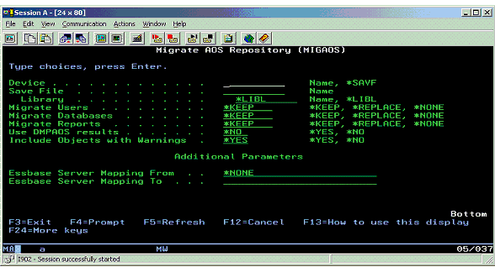

Known Migration Issues

The DMPAOS and MIGAOS commands hang when processing data models
If the DMPAOS and/or MIGAOS commands hang on V5R1, check to see if it is hanging on a data model migration. If so, the data models may have been created before STRATEGY 4.0.

Before you can migrate data models to Analyzer, STRATEGY data models created before STRATEGY 4.50.101 must be opened and saved in STRATEGY 4.50.101 or later, or in STRATEGY 6.5. This patch and subsequent patches include the Query and Report Writer Migration Tool, which will automatically upgrade the internal format of your existing queries, reports, STRATEGY data models, and STRATEGY lookups for use in Analyzer. The instructions for running this tool are in the Enterprise Reporting Administrator’s Guide.

The best solution, since the models must be upgraded before they can be migrated, is to use the latest DBQ3 auto-migration utility to open/save all STRATEGY Data Models (*.SDM) and Lookups (*.SLP). This will make sure UTF-16 files are converted into UTF-8. If this is not done, while the models will not hang the process, they will still not be migrated.

Resolution 32794

When opening a migrated view the user/password prompt for Essbase appears while "Use Analyzer and Essbase security" is used.
The Essbase server is used as authentication server.
This issue does not exist with new views that can be reopened without being prompted for a login twice.
The migration has been done with same Essbase server as target, so the mapping option did not need to be used.

The solution is when migrating, migrate everything including ‘Databases’.
When running the MIGAOS command migrate the databases using the following MIGAOS option:
Migrate Databases . . . . . . *KEEP, *REPLACE, *NONE
Note: Use *REPLACE or *KEEP. (Avoid *NONE)

Resolution 36042

Unable to connect to [database] running DMPAOS
DMPAOS command produces messages in MIGRATE table:
Unable to connect to [database]
Unable to access database [database]
This problem can occur if two library environments are setup for Essbase.

Run DMPAOS command, prompt F4, add additional parameters with F10.
Set the 'Essbase Server Mapping From' and 'Essbase Server Mapping To' to the proper IP addresses for both environments.

Resolution 39186

Troubleshooting
Job Management
The Analyzer install (and subsequently the Analyzer Server) requires a subsystem that allows more than one active job. The subsystem is determined by the job description attached to the profile of the user who is doing the install. If the subsystem has Max Active Jobs = 1, the install will not complete although the server may try to start. Resolution 46317

Connection Issues
Make sure the host servers are started. Resolution 9084
The AS/400 must be networked to the PC from which the install is being run, OR the user must use VPN to connect to the AS/400 to run the installs. Note that remote connections will be extremely slow.

Java Issues
Java must be properly configured on the iSeries. Resolution 8112

Authority Issues
The profile used to install and start the Analyzer server must have *SECOFR user class or equivalent authorities. Resolution 37784

SUPPORT
Before contacting Support for assistance, please review the "What Won't Migrate" section in the Analyzer Migration chapter. There are several functional differences between Analyzer 4.5 and Analyzer 6.21. If assistance is needed, both the Migrate table and the QPJOBLOG should be forwarded to Support.

