LPAR Validation Tool
Users Guide
For pSeries and iSeries Systems
Overview

The LPAR Validation Tool (LVT) is available to assist the user in the design of an LPAR system and to provide an LPAR validation report that reflects the user’s system requirements while not exceeding LPAR recommendations. The user is presumed to have extensive iSeries and pSeries hardware product knowledge and to have a working knowledge of LPAR design requirements, limitations, and recommendations. It is intended to be run on the user’s PC, and is provided AS IS with no implied or expressed warranty of any kind.

The LVT is NOT a marketing configurator, nor is it intended to replace one. It does not (and will not) automatically add hardware features beyond base (9xxx) hardware features and the primary partition console and CD. It will not prevent inefficient system design so long as the design itself meets manufacturing card placement rules and minimum LPAR recommendations.

The LVT is for use on i270/i8xx/i5xx/p5xx LPAR solutions only. It has no capability to support migration towers or any hardware prior to i270/i8xx/i5xx/p5xx. Solutions design for iSeries systems that includes 7xx or older hardware must be done manually using the worksheets provided on the LPAR web site at http://www-1.ibm.com/servers/eserver/iseries/lpar/ and sent to RCHTSC@US.IBM.COM for validation. These worksheets may, and should, be used in combination with the LPAR Validation Tool when the total LPAR solution includes a mixture of i270/i8xx and older hardware.

This Users Guide is comprised of seven sections. The first section gives system requirements to run LVT and a broad explanation of the various screens, their names and intent. The second section consists of an iSeries LPAR configuration while the third section consists of a pSeries LPAR configuration using the LVT. The fourth section contains Frequently Asked Questions. The fifth section contains a list of Enhancements made to the LVT.

Helpful reminders, charts, and recommendations are included throughout this document.

Questions, comments and suggestions are welcome at RCHLVT@US.IBM.COM
Section 1

System Requirements:

- Windows 95 or higher
- 128Mb of memory or greater
- IBM Java Runtime Environment 1.4 is included with the base LVT
- Special Note for users of Win95 or Win98. If you encounter an error stating that you have run out of environment space, the following statement needs to be entered in your config.sys file. SHELL=C:\COMMAND.COM /p /e:1024

Installation Instructions:

- Download the tool to the directory you desire.
- Double click on the .exe. This will extract the LVT and the IBM JRE (Java Runtime Engine) to the appropriate directory it will run out of.
(C:\Program Files\IBM\LVT-V4)
- An icon will be placed called LVT-V4 on your desktop that can be used to launch the application.

Questions, comments and suggestions are welcome at RCHLVT@US.IBM.COM.

Screen Names and Functions:

System Selection
This is the initial definition of any LPAR solution, and from this definition all subsequent calculations are based. The System Selection screen depends on what system type is chosen.

In the case of when an i270/i8xx is selected the following screen is shown below. On this screen are entered System Type, Operating System Version and Release for the Primary Partition, Machine Type, Processor Feature, 5250 Interactive Feature, Memory (in Gigabytes), and the number of desired partitions, etc.

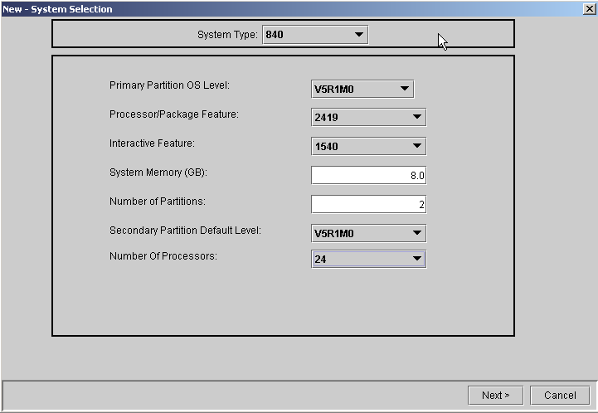

In the case where an i5xx system type is selected the following screen is shown below. On this screen are entered Operating System Version and Release for the Additional Partition Default OS, Machine Type, Processor Feature, Memory (in Gigabytes), and the number of desired partitions, etc. If it is a CUoD machine you can also select the number of active processors.

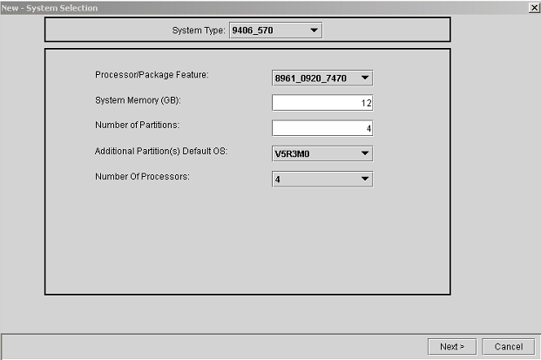

NOTE: This tool is designed for i270/i8xx/i5xx hardware only and will not accommodate 7xx or earlier hardware, including migration towers and any hardware attached through migration towers.
Partition Specification
In the case where i270/i8xx is selected, the screen is divided into three sections. The upper part of the screen is divided vertically into right and left sections. Some data is displayed and will remain static while other fields decrement as the resources they represent are allocated to various partitions. The left section shows the system data as entered in the System Selection screen. The right section displays available resources, which are decremented as they are allocated to various partitions. Note that since rounding is used in the 5250 Interactive calculations, some 5250 Interactive CPW may be left over even though 100% has been allocated. Only two fields in the upper part of the screen require user input. Non-changeable fields will have a gray background.

The table within the middle is where the user inputs individual partition specifications. How many table rows are presented is dependent upon the number of partitions specified in the System Selection screen. Note that the OS Version defaults to the selection level chosen on the System Selection screen. All partitions, except the primary (if using i270/i8xx hardware), may be named if the user desires (8 character maximum length).

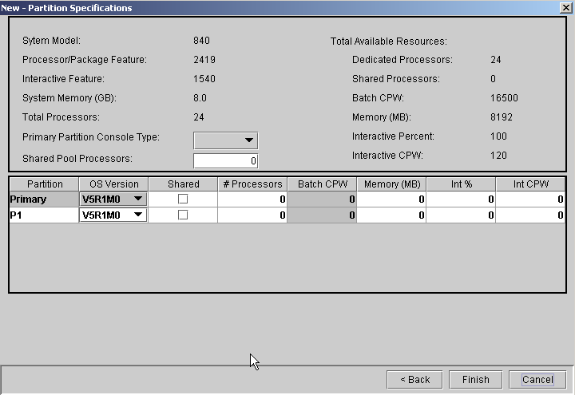

In the case where an i5xx system is selected additional columns will be added for uncapped max. value(s). Notice that for the i5xx all the processors are defaulted to the Shared Pool. This is what actually happens in a real system so that any uncapped partitions may take advantage of the resource. As you assign whole (dedicated) processors to partitions that are not sharing, the Assigned Dedicated Processors field will be incremented. The Shared Pool & Shared Processors fields will be decremented accordingly. The Memory, Int% & Int CPW fields work the same as prior releases but the memory must be assigned to partitions in multiples of 16MB.

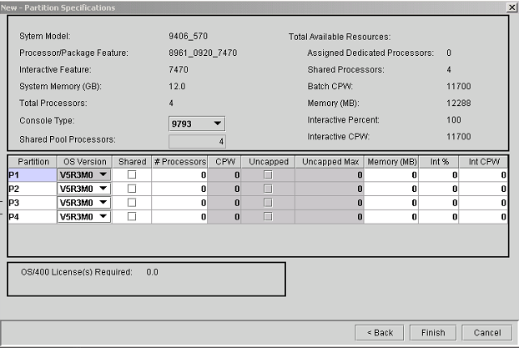

The use of uncapped partitions requires licensing of the operating system for the potential processor/license use based on what the uncapped max value is. The LVT will calculate the required licenses based on the following formula and show that result in the box at the bottom of the frame.
The licensing formula is; Add the (capped + uncap max) OR the shared pool number (whichever is smaller) to the number of dedicated processors. Compare the calculation result to the total number of system processors and use the smaller of the two. Whatever the calculation results are, the number of licenses for the operating system will be limited by the total number of physical processors on the machine.

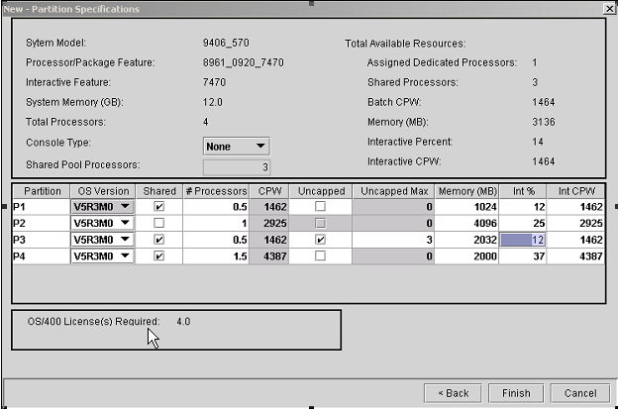
System Layout
This screen is where the detailed system layout is entered. This is done on a card-by-card, tower-by-tower basis. The data must be entered in order of priority: IOPs before IOAs, and IOAs before anything they control (for example disk) that must be placed in the system unit or tower.

The right two thirds of the screen is a diagram of the system, with Add/Remove buttons down its left side. Initially, most slots are empty and the corresponding buttons are labeled “Add”. As each slot becomes populated, its button changes to “Remove”.

On the left third of the screen are lists of features, organized by tabs into the categories of IOPs, IOAs, Drives, and Linux. Features to be added are selected from these lists. If the feature may not be placed where desired, or if a priority must be met, an error will be displayed. A quantity must be entered in the case of disk drives, and a partition number must be specified when adding an IOP or Linux IOA. Only IOAs selected from the Linux category may be placed in Linux partitions. However, Linux does not require any hardware in a partition.

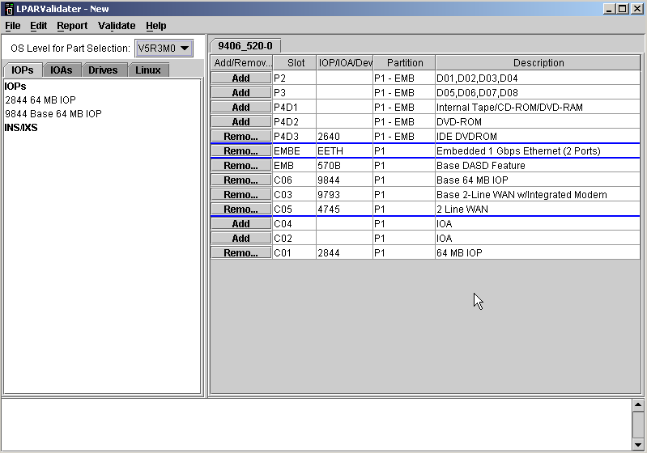

The LVT automatically places base (9xxx) hardware features and an internal CD or DVD in the system unit. The CD or DVD may be removed and replaced with a different option if available so long as the primary partition has CD or DVD support. In i5xx machines there is no ‘primary’ partition so the concern is that there must be a DVD in the system unit.

Internal disk of different capacities may be placed in the same cage, controlled by the same IOA. When this happens, the LVT adds Disk Bay (or DB) lines to the table and labels them with (a), or (b), so that each disk capacity is individually represented.

The lowest portion of the System Layout screen shows two types of messages; informational requirements messages, which address the minimum requirements for each partition and which go away as each are met, and error messages. Only one type of message will show at any given time, with requirement messages being present until either an error message is generated or until the minimum requirements have been met.

Section 2

Using the LPAR Validation Tool to configure a valid iSeries LPAR

Step 1:

From the title bar at the top right of the screen, select FILE, then NEW.
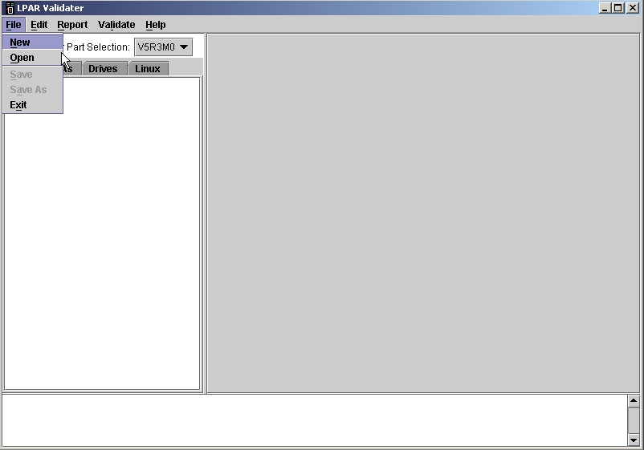

Step 2:

The System Selection screen is then displayed. First a system type must be selected which will show a number of other parameters for configuration. In this example we will configure an i570.

Within the i5xx the controlling operating system release will be V5R3M0 so there is no selection for this like there would be if you selected an i270 or i8xx. Interactive feature is also not a selection within the i5xx.

Then, use the remaining drop down boxes to select the desired Processor/Package Feature as well as the System Memory (GB), Number of Partitions, Additional Partition(s) Default OS and Number of Processors. If the cursor is placed on the various dropdown boxes, flyover text will show the details, such as system CPW, of each available selection in a given box. System memory must be entered in allowable increments for a given system. Those increments and allowable maximum memory amounts are checked and if an incorrect number is entered you will get a message either displaying the maximum or proper increments of memory for that system.

The Number of Processors can be changed if the processor feature you select is a Capacity on Demand system.

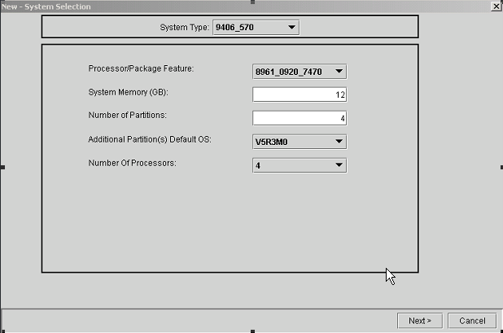

Click Next

Step 3:

The Partition Specification Screen appears next. On the top half of the screen there are two user-input fields, Console Type, and Shared Pool Processors. For pre i5xx systems a console type MUST be selected, but shared pool processors only need to be specified if any partition will use partial processor(s). Note that if a partition, however large, is using a partial processor (e.g. 0.5, 1.2, 5.62, 8.9) then all processing units for that partition must be in the shared pool.
For i5xx systems, selecting Console Type is optional as the Hardware Management Console (HMC) can be the console for any or all partitions. Also as explained in section one (Partition Specification) earlier, all the processors will be defaulted to the shared pool and assignment of dedicated processors will decrement that field.

Select the Primary Partition Console type, and enter the number of shared pool processors if required (pre i5xx)

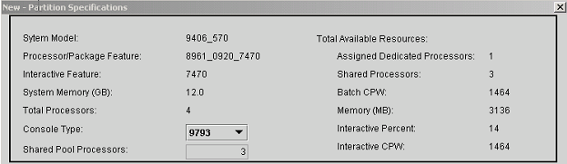
.
On the bottom half of the Partition Specification screen, name the partition, if desired, by clicking in the Partition column and typing in a name (up to 8 characters in length). The primary partition, if using i270/i8xx, cannot be renamed.

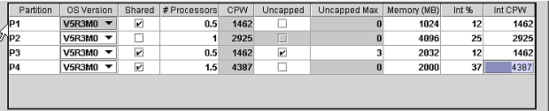

Click in the OS Version column to select the level/type of OS desired for secondary partitions. For pre i5xx systems the primary partition OS Version is fixed based on the data entered in the System Selection Screen. The i5xx systems do not have or need a “primary” partition.

Determine how many processors will be required for the partition. If a fraction of a processor is required, for example 0.5 or 1.5 processors, then check the Shared box. Remember that if partial processors are required in a partition, then all processors to be assigned to that partition must be shared pool processors
Enter the number of processors required for the partition.

Click on Uncapped, if using i5xx models, if you want that partition to have an uncapped max value.

Enter the maximum amount of uncapped processors that will be used for the partition. When all of the processor values are entered (dedicated, capped and uncapped max) the OS/400 licenses that are required will be indicated below.

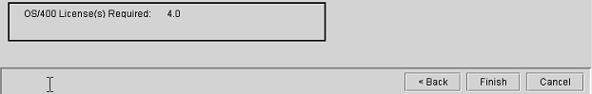
Lastly, enter the amount of 5250 Interactive required for the partition (if applicable), in either the Int% (as a percentage) or Int CPW (as a CPW value). The LVT will do the math to convert CPW to percentages, or percentages to CPW, depending on which table cell is used. Flyover text will show 5250 Interactive minimums and maximums in the Int CPW column. Be aware that the LVT rounds down when converting percentages to CPW. There may be “leftover” 5250 Interactive CPW even though the Int % column totals 100%.

As values are entered in the # Processors, Memory, and Int% or Int CPW columns, notice that the corresponding area in the Available Totals of the upper right side of the screen decrement.

Click Finish (see notes on LAN consoles)

NOTE: V5R2 does not require 5250 interactive in a partition as V5R1 does.

NOTE: If LAN console is desired, then the LAN IOA intended for the console must be DEDICATED to the console. LANs IOAs intended for end-users must be on a separate IOP.

NOTE: If an i5xx is configured with multiple partitions the primary console will be defaulted to the HMC. You can select an additional console if you want.

If LAN console is selected, the LVT will require the primary partition to have a second IOA capable of supporting a “D” mode IPL available to it. IBM strongly recommends having a direct-attach console card (twinax or Operations Console) available to each partition running LAN console. The LAN console card is a dedicated card and can be used for console purposes only. Any external communications for the partition requires a communications card other than the one dedicated to the console.

Step 4:

Next is the System Layout screen. From here the user defines where IOPs, IOAs, disk, and internal removable media will be placed on a slot-by-slot basis. This example shows cards being added to the system unit, but towers may be added and filled at any time and in any order from the System Layout screen.

To add a card, select it from the IOPs, IOAs, Drives, or Linux category. When a card is selected, the slots to which the card can be added will be highlighted. Once you know the slot where you want to add the card click the Add button on the line representing that card slot. The Add button then changes into a Remove button.

Remember that cards must be placed in hierarchical order - IOPs before IOAs and IOAs before devices (e.g. disk, tape). The logic behind this is that a dependent feature cannot be added before its controlling feature, and with PCI in OS/400 there is almost always this slave/master relationship. However, this does not apply to Linux features or the new IOP-less IOAs that can be used in the i5xx family.

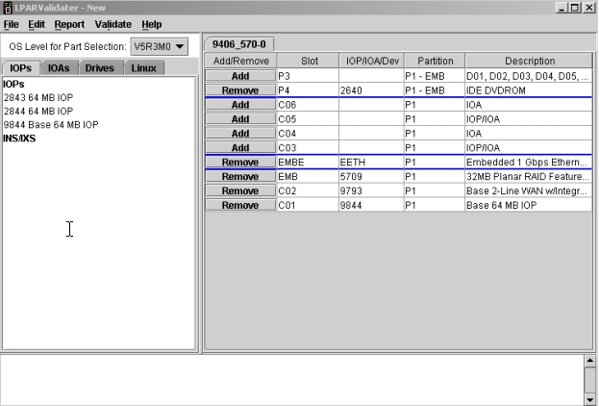

Note that when adding IOPs (and the IOP-less cards), a partition number will need to be specified, and when adding disk both a quantity of disk and its controlling IOA will need to be specified. Note also that Linux does not use IOPs. All Linux cards are under the Linux category and, when added, must be specified as being in a Linux partition. Remember, that Linux does not require hardware in a partition.

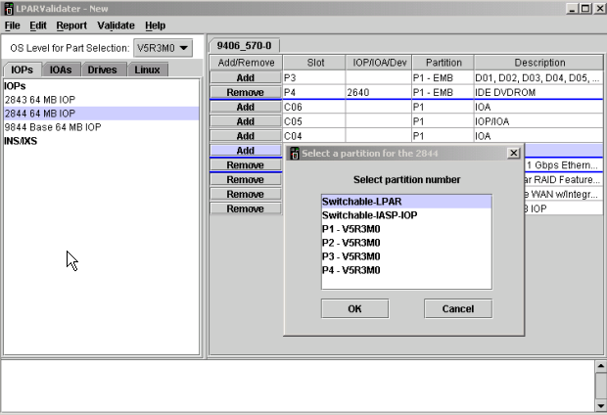

When adding disk, be aware it is possible to have disks of different capacities in the same disk bay. Understanding that, when you add less than the maximum quantity of a disk for a disk bay, the LVT will insert additional lines (labeled, for example, DB3(a) and DB3(b)) to accommodate the ability to add more drives of different capacities in the same disk bay.
Here we are showing a pre i5xx system with a 5079 tower.
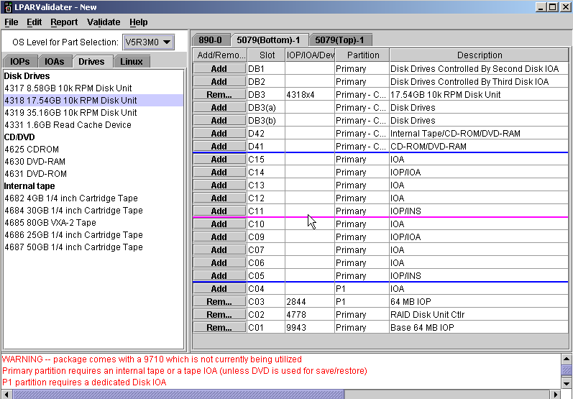

If a feature is not allowed in the slot where the user is attempting to place it, the LVT will issue an error message at the bottom of the screen. This message will temporarily replace the requirement messages that normally appear in the message area.

To remove any feature, simply click the Remove button adjacent to it. Remember that, since features must be added in hierarchical order, so must they be removed. An IOP cannot be removed until all of its dependent IOAs have been removed first. In the next screen capture the IOP to be removed is selected. Since that IOP has no dependent IOAs, just click Remove.
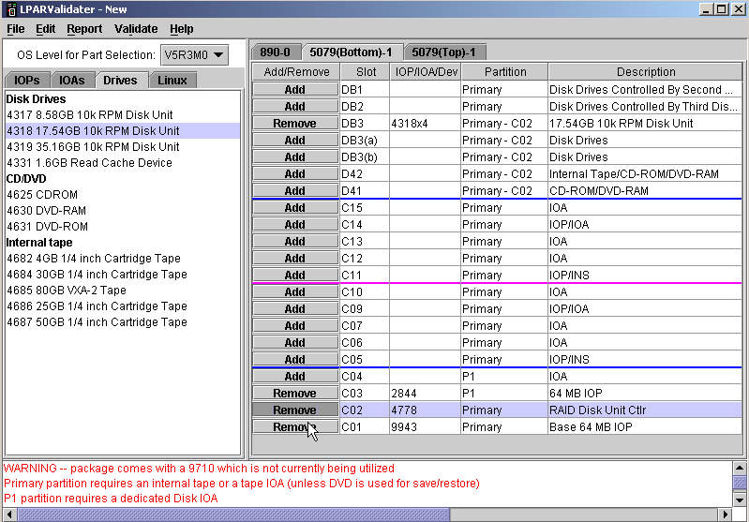

To add a tower, click Edit, then Add Tower.
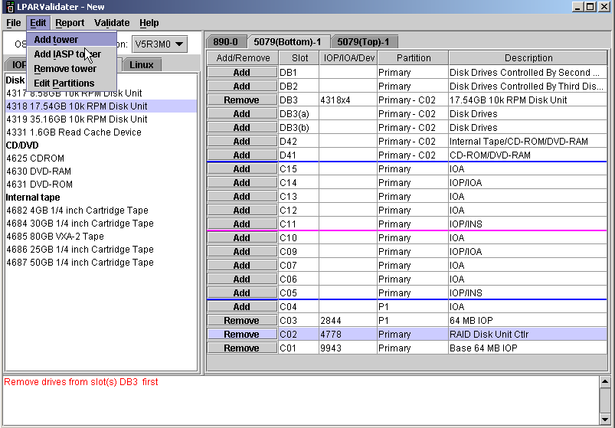
Select the tower to be added, and then click OK.
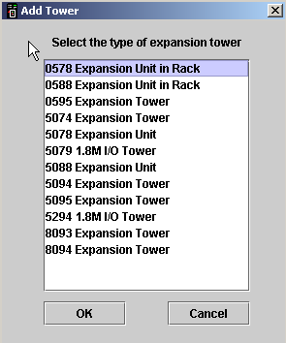

This shows an i570 having added a 5094 tower. Each additional tower has its own tab.

Adding and removing features in a tower is the same as adding and removing features in the system unit.

Adding disk to a 5094 is done as in any other tower but the flexibility and complexity is increased because you can now have 9 groups of 5 disk drives as opposed to only 3 groups of 15 as in earlier towers.
Note the disk location designations are DB3-0, DB3-1, DB3-2, DB1-0, etc.

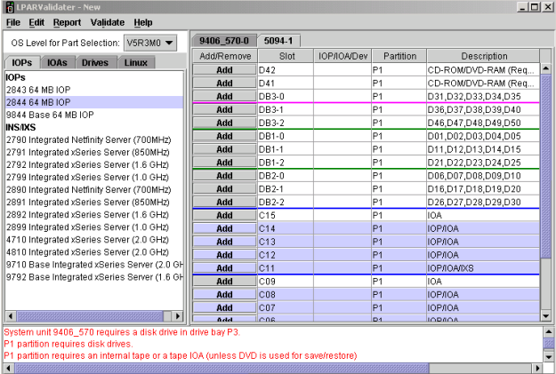

Notice the messages in red at the bottom of the display. These are either informative messages reminding you of what mandatory partition items have not yet been satisfied or ERROR messages regarding an attempt to place a card in an invalid slot or something of that nature.

Editing Partition Information

Certain partition information entered in the System Selection and Partition Specification screens can be modified after leaving those screens.
Simply select Edit and Edit Partitions.

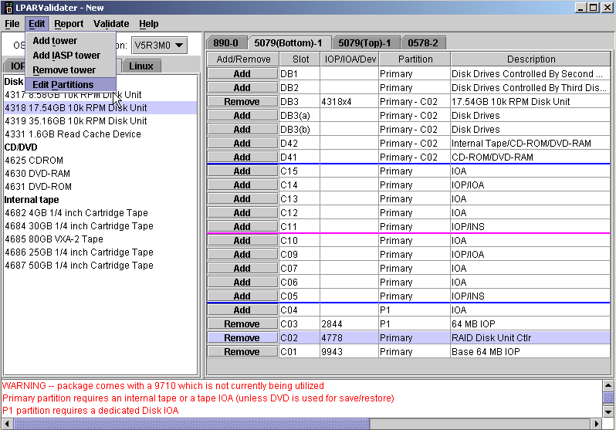

This will bring up the System Selection screen with the non-changeable fields grayed out.

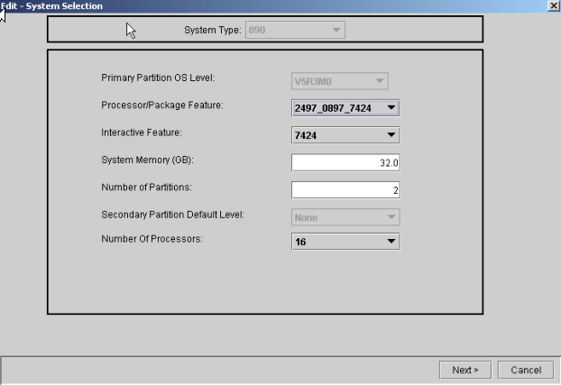
Make any desired changes here, then click Next to return to the Partition Specification screen.

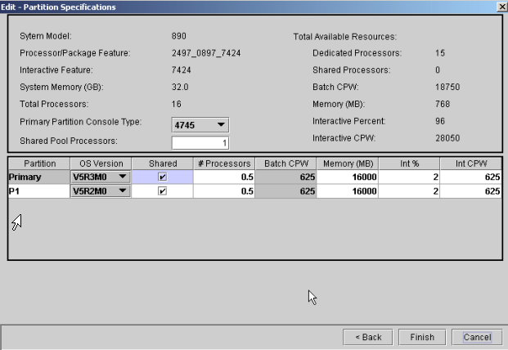
Click Finish to continue to the layout screens to make any changes if needed.
Step 5:
Finally, saving your work. Congratulations! A completed LPAR solution! Now what? Save what has been done, so that effort is not wasted.

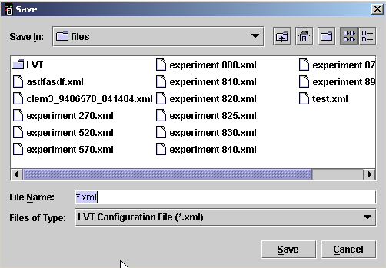
To do this, select File then Save (or Save As). If this is the first time a validation is being saved, enter a file name. Second and subsequent saves will overwrite the file named in the initial save. Do not change the file type! Then click Save. Work can be saved at any point after reaching the System Layout screen.

Working with previously saved LPAR validation files

It is possible to work with LPAR validations that have been saved. Simply click File, then Open.

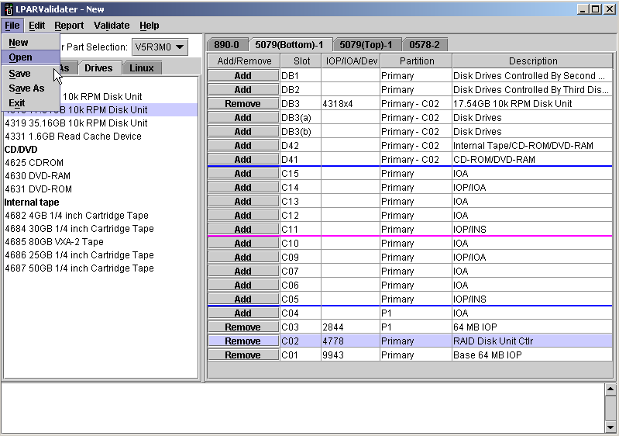
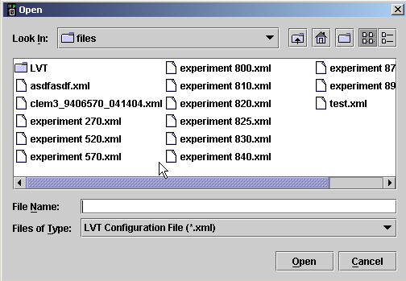
Select the desired file and click Open again
LPAR Validation Report

The LPAR validation report may be viewed or saved to a file at any time after the Partition Specification screen in the validation by clicking Report and then View or Report and then Save or Save As.
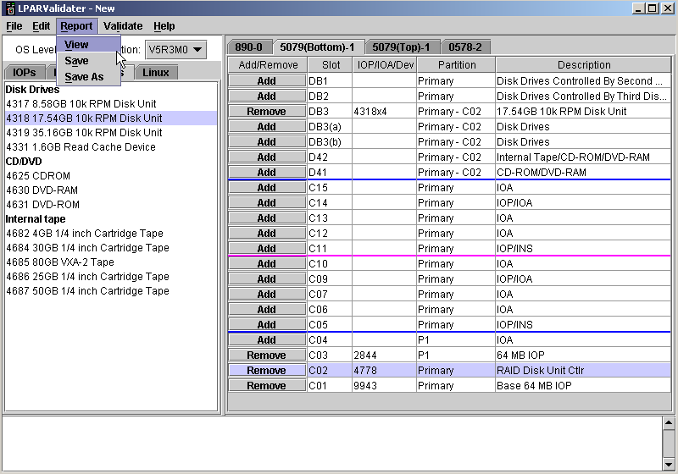
Next visible is the Report - View screen. Select Summary, Detail or All data. While Detail and Summary are separate reports, it is possible to select both. View mode does not allow edit or printing.

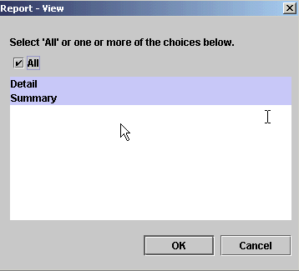

The Report is organized into five sections. The first section is LVT version information. Notice that it has a line called Status

LPAR Validater Tool Report - Detail

Version.............: 4.0502
Description.........: LVT - Detail
Date................: Sun May 02 16:43:33 CDT 2004
Status..............: Valid configuration
Disclaimer..........: This LPAR validation is provided "as is" without warranty of any kind. IBM is not responsible for any items ordered or not ordered as a result of this output.

The second section is titled the System Selections, and reflects the information entered in the System Selection screen.

-- System Selections --
------------------------------------------------------------------------
Primary Partition OS Level..: V5R3M0
System Model................: iSeries Model 9406_570
Processor/Package Feature...: 8961_0919_7488 - Model 9406-570 1/2way 1.
Interactive Feature.........: 7488 - 0 CPW Interactive Package Feature
Console Type................: 9793 - Base 2-Line WAN w/Integrated Modem
System Memory (GB)..........: 12.0
Total Processors............: 2
Dedicated Processors........: 2
Shared Processors...........: 0
Batch CPW...................: 6000
Interactive CPW.............: 0
Total Partitions............: 2
OS/400 Licenses Required....: 2

The third section is called Partition Specifications, and reflects the data entered in the Partition Specification screen.

-- Partition Specifications --

Partition OS Ver Shared # Procs Batch CPW Unc Max Mem (MB) Int % Int CPW
----------------------------------------------------------------------------------
P1 V5R3M0 N 1.00 3000 0 256 0 0
P2 V5R3M0 N 1.00 3000 0 256 0 0
----------------------------------------------------------------------------------
Totals --- --- 2.00 6000 0 512 0 0

The fourth section reflects a detailed list of card and disk placement in a tower-by-tower fashion.

-- Tower Properties --

9406_570-0 -- iSeries Model 9406_570
------------------------------------------------------------------------
Slot Partition Device Description
------------------------------------------------------------------------
P3 P1 - EMB 4326x6 D01, D02, D03, D04, D05, D06
P4 P1 - EMB 2640 IDE DVDROM
++++++++++++++++++++++++++++++++++++++++++++++++++++++++++++++++++++++++
C06 P2 2849 100/10 Mbps Ethernet B
C05 P2 5704 Fiber Channel Tape Ctlr U
C04 P1 5706 1 Gbps Ethernet UTP 2-port S
C03 P2 2844 64 MB IOP #
++++++++++++++++++++++++++++++++++++++++++++++++++++++++++++++++++++++++
EMBE P1 EETH Embedded 1 Gbps Ethernet (2 Ports) B
U
S
#
++++++++++++++++++++++++++++++++++++++++++++++++++++++++++++++++++++++++
EMB P1 5709 32MB Planar RAID Feature Card B
C02 P1 9793 Base 2-Line WAN w/Integrated Modem U
C01 P1 9844 Base 64 MB IOP S
#
------------------------------------------------------------------------
5094-1 -- Expansion Tower
------------------------------------------------------------------------
Slot Partition Device Description
------------------------------------------------------------------------
+++++++++++++++++++++++++++++++++++++++++++++++++++++++++++++++++++++
D42 P2 - C02 None CD-ROM/DVD-RAM (Required)
D41 P2 - C02 4630 DVD-RAM
DB3-0 P2 - C02 4326x5 D31,D32,D33,D34,D35
++++++++++++++++++++++++++++++++++++++++++++++++++++++++++++++++++
DB3-1 P2 - C02 4326x5 D36,D37,D38,D39,D40
DB3-2 P1 None D46,D47,D48,D49,D50
DB1-0 P1 None D01,D02,D03,D04,D05
DB1-1 P1 None D11,D12,D13,D14,D15
DB1-2 P1 None D21,D22,D23,D24,D25
DB2-0 P1 None D06,D07,D08,D09,D10
DB2-1 P1 None D16,D17,D18,D19,D20
DB2-2 P1 None D26,D27,D28,D29,D30
+++++++++++++++++++++++++++++++++++++++++++++++++++++++++++++++++++++
C15 Sw-LPAR None IOA B
C14 Sw-LPAR None IOP/IOA U
C13 Sw-LPAR None IOP/IOA S
C12 Sw-LPAR 5712 PCI-X U320 Tape Controller #
C11 Sw-LPAR 2844 64 MB IOP
+++++++++++++++++++++++++++++++++++++++++++++++++++++++++++++++++++++
C09 P2 None IOA B
C08 P2 None IOP/IOA U
C07 P2 None IOP/IOA S
C06 P2 5702 Ultra Tape Controller #
C05 P2 2844 64 MB IOP
+++++++++++++++++++++++++++++++++++++++++++++++++++++++++++++++++++++
C04 P2 2793 2-Line WAN w/Integrated Modem B
C03 P2 2849 100/10 Mbps Ethernet U
C02 P2 2757 RAID Disk Unit Ctlr S
C01 P2 9844 Base 64 MB IOP #
-----------------------------------------------------------------------

The fifth and final section is the Summary, which, as one might expect, summarizes all towers and cards in the LPAR solution.

LPAR Validater Tool Report - Summary

Version.............: 4.0502
Description.........: LVT - Summary
Date................: Sun May 02 16:43:33 CDT 2004
Status..............: Valid configuration
Disclaimer..........: This LPAR validation is provided "as is" without
warranty of any kind. IBM is not responsible for
items ordered or not ordered as a result of this
output.

This section shows the quantity of features by partition.

Partitions..........: 2

Feature Code P1 P2 -- --
------------------------------------------------------------------------
0140 1 1 0 0
0919 0 0 0 0
2640 1 0 0 0
2757 0 1 0 0
2793 0 1 0 0
2844 0 2 0 0
2849 0 2 0 0
4326 6 10 0 0
4630 0 1 0 0
5094 0 0 0 0
5702 0 1 0 0
5704 0 1 0 0
5706 0 1 0 0
5709 1 0 0 0
5712 0 0 0 0
7488 0 0 0 0
8961 0 0 0 0
9793 1 0 0 0
9844 1 1 0 0

Feature Code Sw-LPAR Sw-IASP-IOP Sw-IASP-TWR
------------------------------------------------------------------------
0140 0 0 0
0919 0 0 0
2640 0 0 0
2757 0 0 0
2793 0 0 0
2844 1 0 0
2849 0 0 0
4326 0 0 0
4630 0 0 0
5094 0 0 0
5702 0 0 0
5704 0 0 0
5706 0 0 0
5709 0 0 0
5712 1 0 0
7488 0 0 0
8961 0 0 0
9793 0 0 0
9844 0 0 0

This section shows a total for all the feature codes in the entire design.

Feature Code Description Total

------------------------------------------------------------------------
0140 Logical Partitioning Specify 2
0919 Model 9406-570 1/2way 1.65 Ghz Standard Editi 1
2640 IDE DVDROM 1
2757 RAID Disk Unit Ctlr 1
2793 2-Line WAN w/Integrated Modem 1
2844 64 MB IOP 3
2849 100/10 Mbps Ethernet 2
4326 35.16GB 15k RPM Disk Unit 16
4630 DVD-RAM 1
5094 Expansion Tower 1
5702 Ultra Tape Controller 1
5704 Fiber Channel Tape Ctlr 1
5706 1 Gbps Ethernet UTP 2-port 1
5709 32MB Planar RAID Feature Card 1
5712 PCI-X U320 Tape Controller 1
7488 0 CPW Interactive Package Feature 1
8961 Model 9406-570 1/2way 1.65 Ghz Standard Editi 1
9793 Base 2-Line WAN w/Integrated Modem 1
9844 Base 64 MB IOP 2

From this report, services personnel will be able to create partitions and place cards, disk, internal tape, etc.

Section 3

Using the LPAR Validation Tool to configure a valid pSeries LPAR

Step 1:

From the title bar at the top right of the screen, select FILE, then NEW.

Step 2:

The System Selection screen is then displayed. First a system type must be selected which will show a number of other parameters for configuration. In this example we will configure an p520.

It is important to choose Partition 1 Operating System level which allows you to choose between AIX_52, AIX_53, AIX_53_HOST, AIX_53_HOSTED, LINUX and LINUX_HOSTED.

Then, use the remaining drop down boxes to select the desired Processor/Package Feature as well as the System Memory (GB), Number of Partitions, Additional Partition(s) Default OS and Number of Processors. If the cursor is placed on the various dropdown boxes, flyover text will show the details. For example, if you were to put your mouse over a processor while selecting one text will be shown describing the processor. System memory must be entered in allowable increments for a given system. Those increments and allowable maximum memory amounts are checked and if an incorrect number is entered you will get a message either displaying the maximum or proper increments of memory for that system.

The Number of Processors can be changed if the processor feature you select is a Capacity on Demand system.

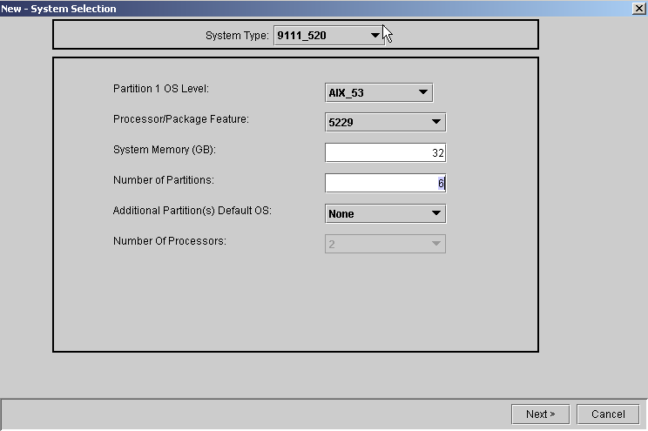

Click Next

Step 3:

The Partition Specification Screen appears next.

On the left hand side of the screen information will be shown about what was selected on the prior screen. The Total Available Resources will decrement or increment depending on how you configure the different partitions.

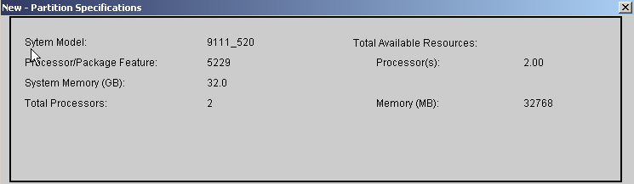
.
On the bottom half of the Partition Specification screen, name the partition, if desired, by clicking in the Partition column and typing in a name (up to 8 characters in length).
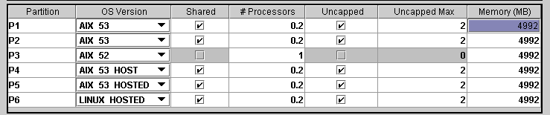

Click in the OS Version column to select the level/type of OS desired for secondary partitions.
Determine how many processors will be required for the partition. If a fraction of a processor is required, for example 0.5 or 1.5 processors, then check the Shared box. Remember that if partial processors are required in a partition, then all processors to be assigned to that partition must be shared pool processors
Enter the number of processors required for the partition.

Click on Uncapped, if using p5xx models, if you want that partition to have an uncapped max value.

Enter the maximum amount of uncapped processors that will be used for the partition. When all of the processor values are entered (dedicated, capped and uncapped max) the OS/400, AIX and Linux licenses that are required will be indicated below.

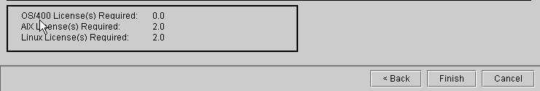

Click Finish (see notes on LAN consoles)
Step 4:

Next is the System Layout screen. From here the user defines where IOAs, disk, and internal removable media will be placed on a slot-by-slot basis. This example shows cards being added to the system unit, but towers may be added and filled at any time and in any order from the System Layout screen.

To add a card, select it from the IOAs, Drives, or Linux category. When a card is selected, the slots to which the card can be added will be highlighted. Once you know the slot where you want to add the card click the Add button on the line representing that card slot. The Add button then changes into a Remove button.

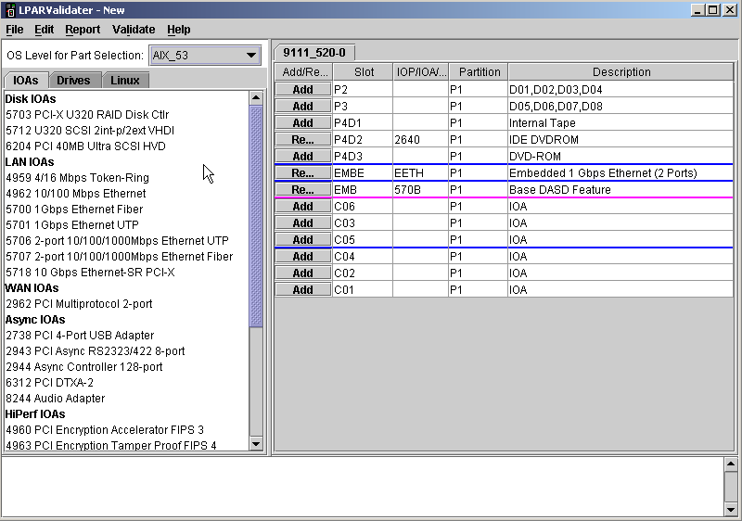

Now we must add different parts into the system unit to make sure we meet all the partition requirements. You can always do a Validate → Validate Partitions or an Alt-V which will end up outputting messages below. These messages will help you configure a valid LPAR system.
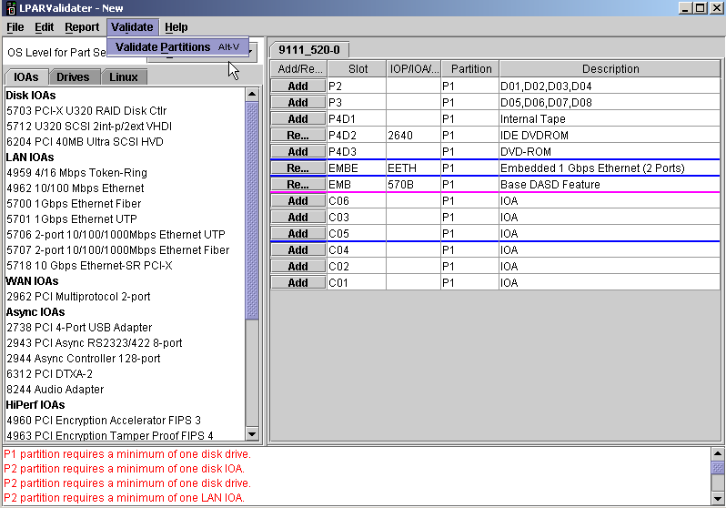
We will first add disk drives within the system unit. When selecting the disk drive and the slot it is going to be added to you will be asked to select how many drives that you want to go in that slot. This will default to be controlled by the embedded IOA.

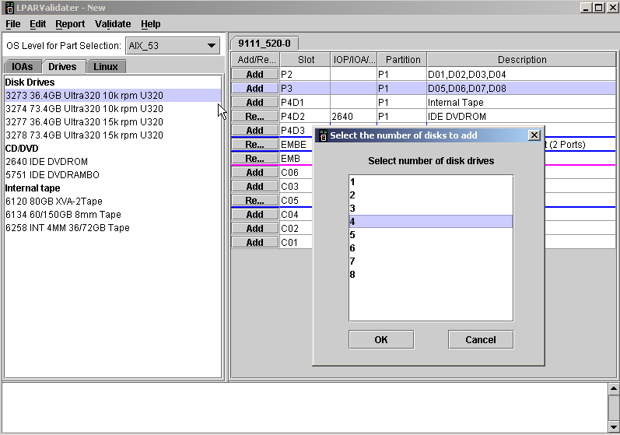

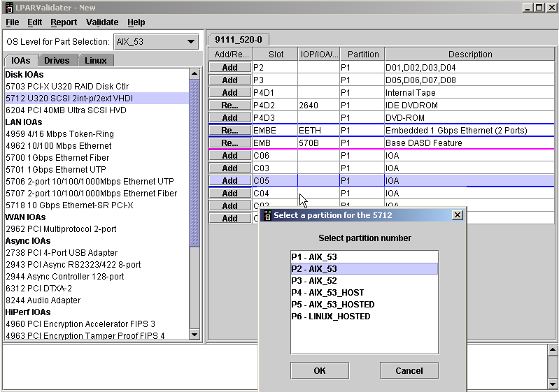
We will then add an 5712 IOA to our 520 system. When you highlight a part on the left the different slots will be highlighted on the right. These slots that are highlighted within the tower are the valid slots that are supported for the part that was selected. Once you choose the slot you will be asked which partition should this part be assigned to. Once you select the partition it will put the part within the slot that was specified.

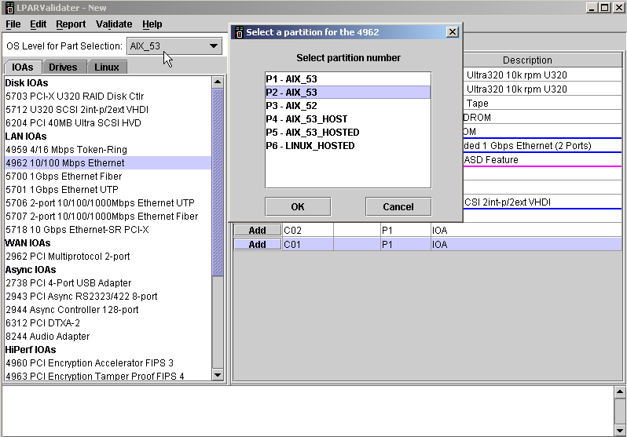
Next we must meet the communication requirements by adding a LAN IOA.
We will add disk drives but notice how this time it asks us which Controlling IOA do we want to use.
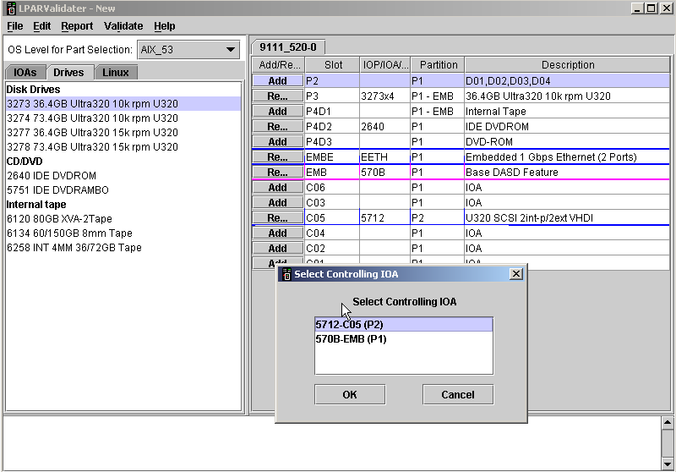

You can then add different expansion towers by doing an Edit → Add tower.
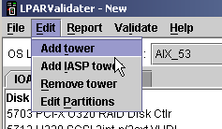

A list of expansion towers will be shown to you. Select the tower you wish to add to your LPAR configuration and hit OK.
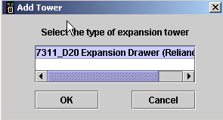

The expansion tower that you selected will then be added to the configuration.

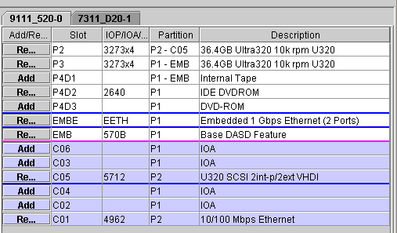

In this example we added 4 expansion towers. Notice the configuration errors that are displayed in red below.

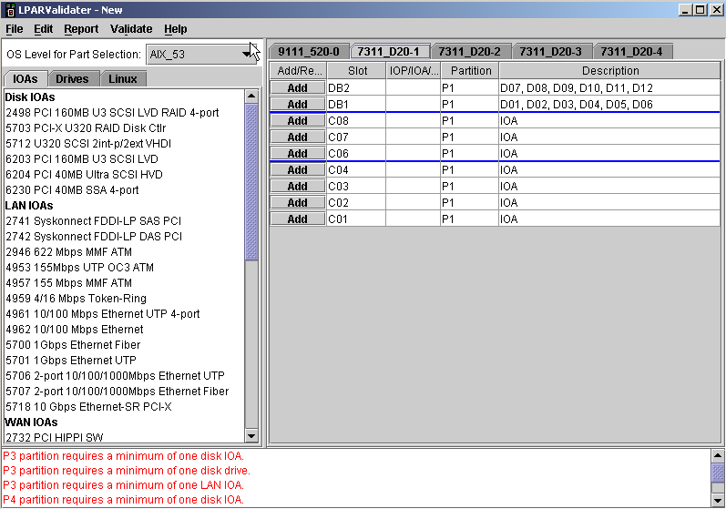

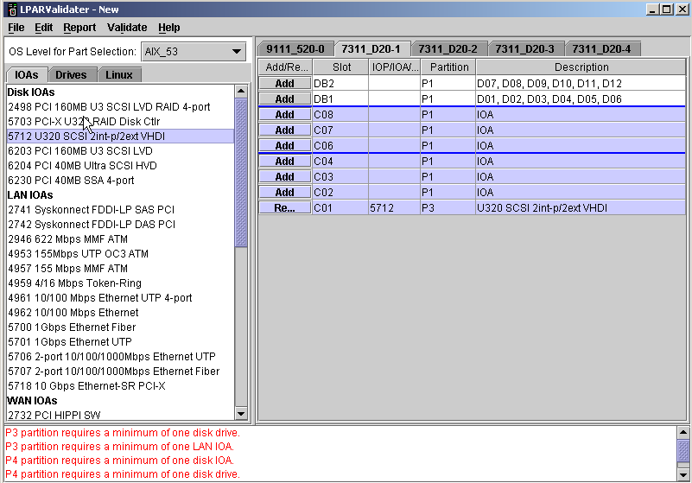
We will add a 5712 IOA to P3.

We will add disk drives controlled by the IOA in C01.

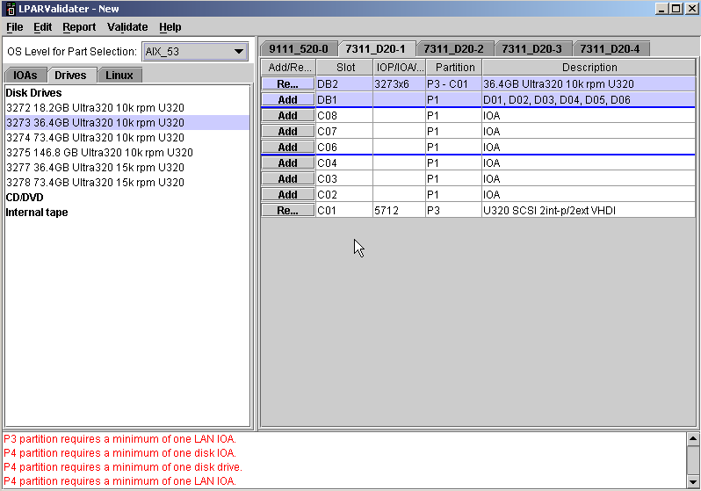

We added another IOA to this expansion tower along with a disk drive.
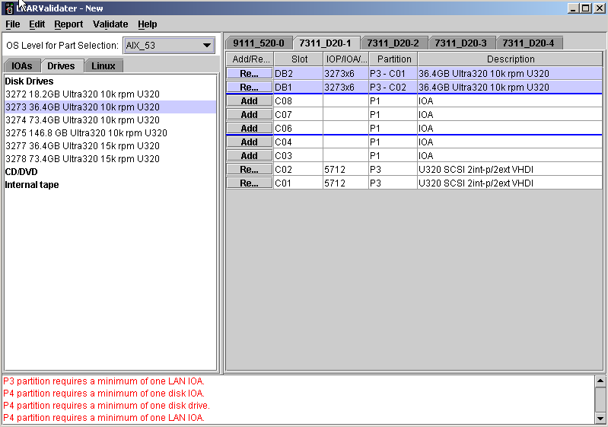
We then added a 4962 LAN IOA that will fulfill communication requirements.
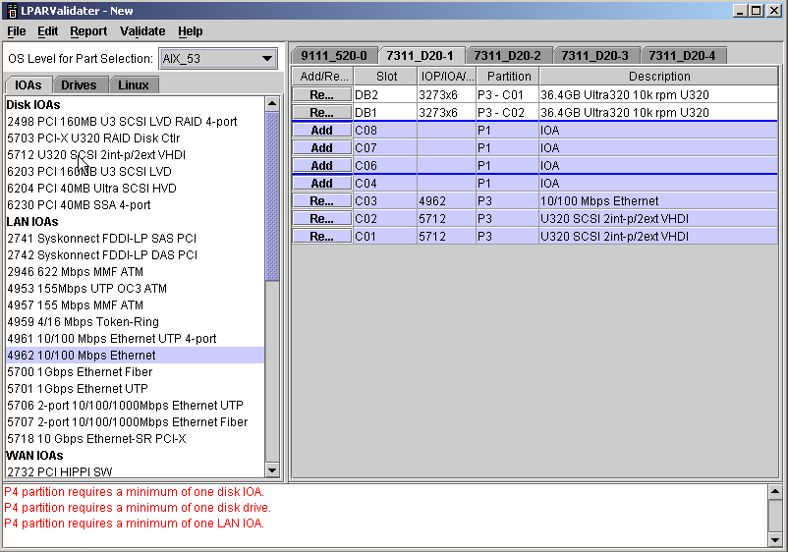

We will then configure the 4th partition in the second expansion tower. We first add 2 5712 IOAs.
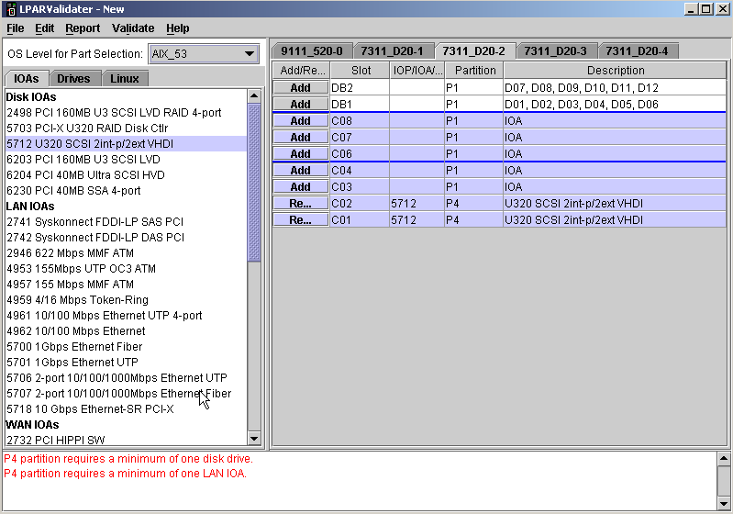
We will then add disk drives controlled by the IOAs in C01 and C02.
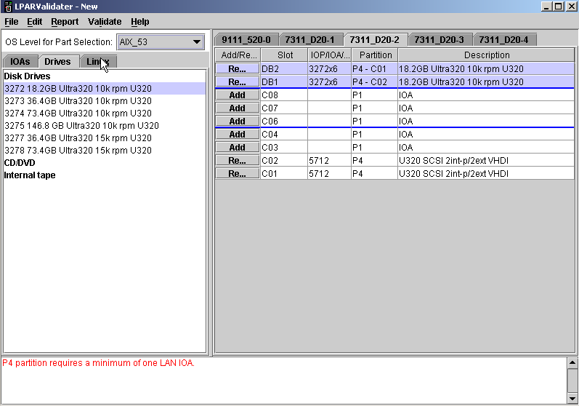

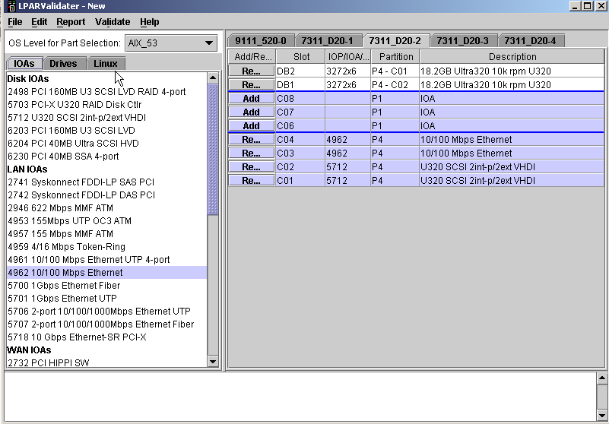
We will then add the 4962 LAN IOA to meet communications requirements.

We will configure the 3rd expansion tower for our 5th partition.
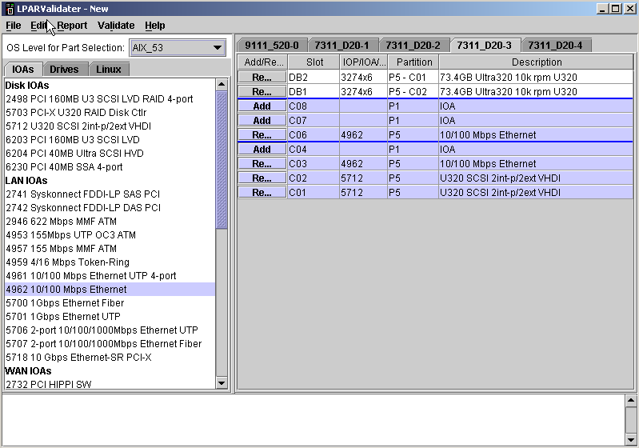

We will then configure the last expansion tower for partition P6.
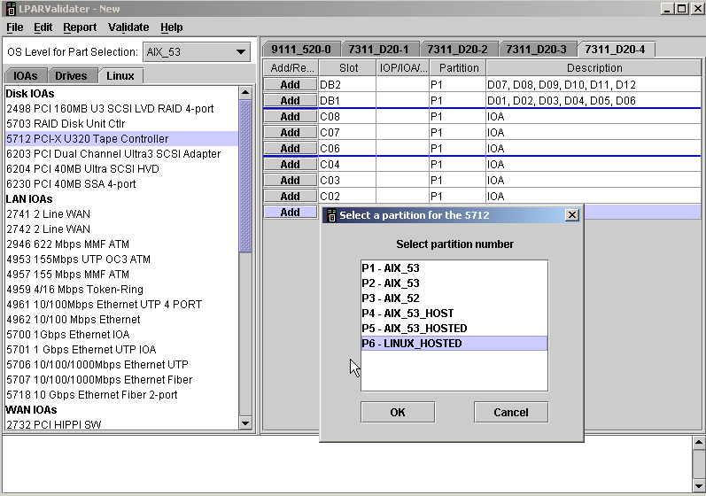
Final look of the last tower.
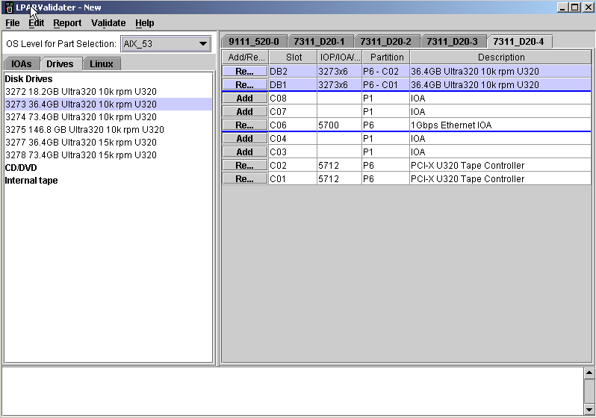
Once we are done configuring a valid LPAR we can view the report. This can be used to paste into a word document for printing.
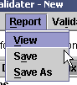

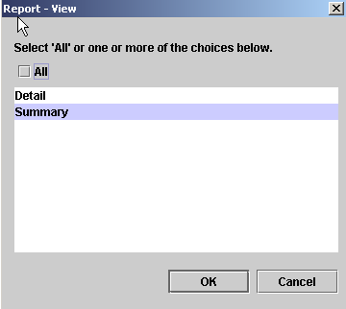
Can view the Summary or the Details.

This is an example of what the report looks like.

LPAR Validater Tool Report - Detail

Version.............: 4.0709GA2
Description.........: LVT - Detail
Date................: Fri Jul 09 17:08:44 CDT 2004
Status..............: Valid configuration
- WARNING -- partition hardware may be
installed in migration towers and cannot be
accounted for by the LPAR validation tool
- WARNING -- when a 2749 attaches a 3995
Optical Library DataServer, the 2749 must not be
placed under the same IOP which drives the Load
Source DASD

IT IS THE USER'S RESPONSIBILITY TO ENSURE THAT
ALL PARTITION REQUIREMENTS ARE MET.

Disclaimer..........: This LPAR validation is provided "as is" without
warranty of any kind. IBM is not responsible for
items ordered or not ordered as a result of this
output.

Warning.............: The output of this tool displays the parts
placement required for the partitions you have
defined, but IBM manufacturing places the parts
for a single partition system only. It is the
customer responsibility to move the parts for
the customized partitioning. IBM services are
available for a fee to perform this placement if
requested.

Warning.............: It is strongly recommended that you do capacity
planning for the workload planned in each
partition and then determine the LPAR
configuration required to achieve the desired
performance and room for growth in that
partition. For planning purposes, allow for up
to 10% performance overhead in a partition using
shared processors. For additional information,
please see
http://www-1.ibm.com/servers/eserver/iseries/lpa
r/capacityplan.htm

Warning.............: Warning - The 5705 can drive internal disk and an
external tape or DVD. However, in a LPAR system,
when the 5705 is used in a secondary partition
for the partition load source disk, an external
tape or DVD that is also attached cannot be used
as an ALT IPL device for that partition.

-- System Selections --
------------------------------------------------------------------------
Primary Partition OS Level..: AIX_53
System Model................: pSeries Model 520
Processor/Package Feature...: 5229 - Model 9111-520 2-way
Interactive Feature.........: N/A
Console Type................: N/A
System Memory (GB)..........: 32.0
Total Processors............: 2
Dedicated Processors........: 1
Shared Processors...........: 1.0
Batch CPW...................: 0
Interactive CPW.............: 0
Total Partitions............: 6
OS/400 Licenses Required....: 0
AIX Licenses Required.......: 2
Linux Licenses Required.....: 2

-- Partition Specifications --
Partition OS Ver Shared # Procs Batch CPW Unc Max Mem (MB)
-----------------------------------------------------------------------------
P1 AIX_53 Y 0.20 0 2 4992
P2 AIX_53 Y 0.20 0 2 4992
P3 AIX_52 N 1.00 0 0 4992
P4 AIX_53_HOST Y 0.20 0 2 4992
P5 AIX_53_HOSTED Y 0.20 0 2 4992
P6 LINUX_HOSTED Y 0.20 0 2 4992
-----------------------------------------------------------------------------
Totals ------ --- 2.00 0 10 29952

-- Tower Properties --

9111_520-0 -- pSeries Model 520
------------------------------------------------------------------------
Slot Partition Device Description
------------------------------------------------------------------------
P2 P2 - C05 3273x4 36.4GB Ultra320 10k rpm U320
P3 P1 - EMB 3273x4 36.4GB Ultra320 10k rpm U320
P4D1 P1 - EMB None Internal Tape
P4D2 P1 2640 IDE DVDROM
P4D3 P1 None DVD-ROM
++++++++++++++++++++++++++++++++++++++++++++++++++++++++++++++++++++
EMBE P1 EETH Embedded 1 Gbps Ethernet (2 Ports)
++++++++++++++++++++++++++++++++++++++++++++++++++++++++++++++++++++
EMB P1 570B Base DASD Feature
++++++++++++++++++++++++++++++++++++++++++++++++++++++++++++++++++
C06 P1 None IOA
C03 P1 None IOA
C05 P2 5712 U320 SCSI 2int-p/2ext VHDI

++++++++++++++++++++++++++++++++++++++++++++++++++++++++++++++++++++
C04 P1 None IOA
C02 P1 None IOA
C01 P2 4962 10/100 Mbps Ethernet
------------------------------------------------------------------------

7311_D20-1 -- Expansion Drawer (Reliance-g 4U)
------------------------------------------------------------------------
Slot Partition Device Description
------------------------------------------------------------------------

+++++++++++++++++++++++++++++++++++++++++++++++++++++++++++++++++++
DB2 P3 - C01 3273x6 36.4GB Ultra320 10k rpm U320
DB1 P3 - C02 3273x6 36.4GB Ultra320 10k rpm U320
+++++++++++++++++++++++++++++++++++++++++++++++++++++++++++++++++++++
C08 P1 None IOA
C07 P1 None IOA
C06 P1 None IOA ++++++++++++++++++++++++++++++++++++++++++++++++++++++++++++++++++++
C04 P1 None IOA
C03 P3 4962 10/100 Mbps Ethernet
C02 P3 5712 U320 SCSI 2int-p/2ext VHDI
C01 P3 5712 U320 SCSI 2int-p/2ext VHDI

------------------------------------------------------------------------

7311_D20-2 -- Expansion Drawer (Reliance-g 4U)
------------------------------------------------------------------------
Slot Partition Device Description
------------------------------------------------------------------------
++++++++++++++++++++++++++++++++++++++++++++++++++++++++++++++++++++
DB2 P4 - C01 3272x6 18.2GB Ultra320 10k rpm U320
DB1 P4 - C02 3272x6 18.2GB Ultra320 10k rpm U320
++++++++++++++++++++++++++++++++++++++++++++++++++++++++++++++++++++
C08 P1 None IOA
C07 P1 None IOA
C06 P1 None IOA
++++++++++++++++++++++++++++++++++++++++++++++++++++++++++++++++++++
C04 P4 4962 10/100 Mbps Ethernet
C03 P4 4962 10/100 Mbps Ethernet
C02 P4 5712 U320 SCSI 2int-p/2ext VHDI
C01 P4 5712 U320 SCSI 2int-p/2ext VHDI

------------------------------------------------------------------------

7311_D20-3 -- Expansion Drawer (Reliance-g 4U)
------------------------------------------------------------------------
Slot Partition Device Description
------------------------------------------------------------------------

++++++++++++++++++++++++++++++++++++++++++++++++++++++++++++++++++++
DB2 P5 - C01 3274x6 73.4GB Ultra320 10k rpm U320
DB1 P5 - C02 3274x6 73.4GB Ultra320 10k rpm U320
+++++++++++++++++++++++++++++++++++++++++++++++++++++++++++++++++++++
C08 P1 None IOA
C07 P1 None IOA
C06 P5 4962 10/100 Mbps Ethernet
++++++++++++++++++++++++++++++++++++++++++++++++++++++++++++++++++++
C04 P1 None IOA
C03 P5 4962 10/100 Mbps Ethernet
C02 P5 5712 U320 SCSI 2int-p/2ext VHDI
C01 P5 5712 U320 SCSI 2int-p/2ext VHDI
------------------------------------------------------------------------

7311_D20-4 -- Expansion Drawer (Reliance-g 4U)
------------------------------------------------------------------------
Slot Partition Device Description
------------------------------------------------------------------------
++++++++++++++++++++++++++++++++++++++++++++++++++++++++++++++++++++
DB2 P6 - C02 3273x6 36.4GB Ultra320 10k rpm U320
DB1 P6 - C01 3273x6 36.4GB Ultra320 10k rpm U320
+++++++++++++++++++++++++++++++++++++++++++++++++++++++++++++++++++++
C08 P1 None IOA
C07 P1 None IOA
C06 P6 5700 1Gbps Ethernet IOA
+++++++++++++++++++++++++++++++++++++++++++++++++++++++++++++++++++++
C04 P1 None IOA
C03 P1 None IOA
C02 P6 5712 PCI-X U320 Tape Controller
C01 P6 5712 PCI-X U320 Tape Controller

------------------------------------------------------------------------

LPAR Validater Tool Report - Summary

Version.............: 4.0709GA2
Description.........: LVT - Summary
Date................: Fri Jul 09 17:08:44 CDT 2004
Status..............: Valid configuration
- WARNING -- partition hardware may be
installed in migration towers and cannot be
accounted for by the LPAR validation tool
- WARNING -- when a 2749 attaches a 3995
Optical Library DataServer, the 2749 must not be
placed under the same IOP which drives the Load
Source DASD
IT IS THE USER'S RESPONSIBILITY TO ENSURE THAT
ALL PARTITION REQUIREMENTS ARE MET.

Disclaimer..........: This LPAR validation is provided "as is" without
warranty of any kind. IBM is not responsible for
items ordered or not ordered as a result of this
output.

Warning.............: The output of this tool displays the parts
placement required for the partitions you have
defined, but IBM manufacturing places the parts
for a single partition system only. It is the
customer responsibility to move the parts for
the customized partitioning. IBM services are
available for a fee to perform this placement if
requested.

Warning.............: It is strongly recommended that you do capacity
planning for the workload planned in each
partition and then determine the LPAR
configuration required to achieve the desired
performance and room for growth in that
partition. For planning purposes, allow for up
to 10% performance overhead in a partition using
shared processors. For additional information,
please see
http://www-1.ibm.com/servers/eserver/iseries/lpa
r/capacityplan.htm

Warning.............: Warning - The 5705 can drive internal disk and an
external tape or DVD. However, in a LPAR system,
when the 5705 is used in a secondary partition
for the partition load source disk, an external
tape or DVD that is also attached cannot be used
as an ALT IPL device for that partition.
Partitions..........: 6

Feature Code P1 P2 P3 P4

------------------------------------------------------------------------
0142 0 0 0 0
0145 1 1 1 1
2640 1 0 0 0
3272 0 0 0 2
3273 1 1 2 0
3274 0 0 0 0
4962 0 1 1 2
5229 0 0 0 0
5700 0 0 0 0
5712 0 0 0 0
5712 0 1 2 2

Feature Code P5 P6 -- --
------------------------------------------------------------------------
0142 0 1 0 0
0145 1 0 0 0
2640 0 0 0 0
3272 0 0 0 0
3273 0 2 0 0
3274 2 0 0 0
4962 2 0 0 0
5229 0 0 0 0
5700 0 1 0 0
5712 0 2 0 0
5712 2 0 0 0

Feature Code Sw-LPAR Sw-IASP-IOP Sw-IASP-TWR
------------------------------------------------------------------------
0142 0 0 0
0145 0 0 0
2640 0 0 0
3272 0 0 0
3273 0 0 0
3274 0 0 0
4962 0 0 0
5229 0 0 0
5700 0 0 0
5712 0 0 0
5712 0 0 0

Feature Code Description Total
------------------------------------------------------------------------
0142 Linux Partition Specify 1
0145 AIX Partition Specify 5
2640 IDE DVDROM 1
3272 18.2GB Ultra320 10k rpm U320 2
3273 36.4GB Ultra320 10k rpm U320 6
3274 73.4GB Ultra320 10k rpm U320 2
4962 10/100 Mbps Ethernet 6
5229 Model 9111-520 2-way 1
5700 1Gbps Ethernet IOA 1
5712 PCI-X U320 Tape Controller 2
5712 U320 SCSI 2int-p/2ext VHDI 7

* * * * END OF REPORT * * * * *

Step 5:
Finally, saving your work. Congratulations! A completed LPAR solution! Now what? Save what has been done, so that effort is not wasted.
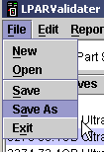
To do this, select File then Save (or Save As). If this is the first time a validation is being saved, enter a file name. Second and subsequent saves will overwrite the file named in the initial save. Do not change the file type! Then click Save. Work can be saved at any point after reaching the System Layout screen.
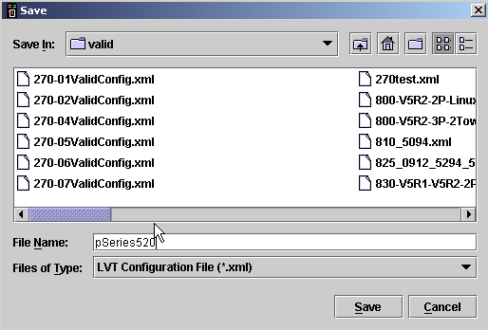

Section 4
FAQs:

Q: Where do I get the LPAR validation tool?
A: It’s on the LPAR web site for download to your PC at http://www-1.ibm.com/servers/eserver/iseries/lpar/

Q: How do I tell what is the most current version of the LVT?
A: The version number of the LVT is posted with the tool on the website above.

Q: How do I know what version of the LVT I have?
A: Click Help, then About LPAR Validater, and the version number will be displayed.

Q: How often will the LPAR Validation Tool be updated? How often should I refresh my copy of it?
A: Updates will be posted as often as necessary, generally every 1-4 weeks.

Q: Why can’t I change the processor feature when I edit the system selection screen?
A: Editing the processor feature can affect secondary partitions, as some features don’t allow V4R5 in a secondary.

Q: Why can’t I add this feature to my LPAR solution?
A: A number of reasons prevent adding a feature. Generally speaking, either weighting or positioning prevents a feature IOA from being added. Only four IOAs may be placed on any one IOP, and those four may not exceed the capabilities of the IOP.

Q: Why does the LVT allow me to add withdrawn features?
A: The LVT is not a marketing configurator, and has no knowledge of feature availability. If a feature is valid for an LPAR solution, it is included in the LVT.

Q: Why can’t I have Linux as a secondary partition in this LPAR solution?
A: Linux can only be a secondary partition if the primary partition is V5R1 or higher.

Q: Why won’t the LVT allow me to configure Linux on this solution when my primary is on V5R1?
A: Linux support capability is limited not only by the OS level of the primary partition, but also by the Model/Processor of the box. See the LPAR Capabilities by Model charts on the LPAR web site: http://www-1.ibm.com/servers/eserver/iseries/lpar

Q: Can I have a Linux partition without any Linux features selected?
A: Yes. Linux has no I/O requirements.
Q: On a 2-way i820 my partial processors are allocated 0.6 and 0.5 and 0.8 and 0.1. This means at least one partition works on both processors. Is this possible?
A: This is valid because the system does not separate the processors and allocate them so that the same partial processor is always dedicated to the same partition. The system works out of the shared processor pool and the same processor will not always be used in the partition. It used that particular amount of a processor in the shared pool.

Q: LVT is allowing me to have unassigned processor and memory resources. Is this right?
A: Yes. There is no requirement to allocate all processors and memory.

Q: Why does the LVT sometimes skip tower numbers?
A: Removing a tower that was added causes skipped tower numbers. LVT keeps track of all towers, even removed ones, for summary purposes.

Q: I cannot view my report in a readable format after I have saved it. What am I doing wrong?
A: You need to get the Microsoft Word viewer and open the file with it. It can be downloaded free from the following website: http://support.microsoft.com/support/kb/articles/q165/9/08.asp

Q: Why can’t I resize the message window?
A: LVT was designed to not allow the window to be resized. The messages pertaining to partition requirements disappear as the requirements are met. When an error occurs, the partition requirements messages disappear until the error is corrected. There is a navigation bar on the right side of the window that allows navigation to messages that you can’t see.

Q: Is a disk IOA allowed on a switchable IOP?
A: Yes. The disk IOA is allowed on a switchable IOP because the tool can be used for clustering with switched disk support or to design switchable towers. You can also switch a CD-ROM by placing it in a tower CD-ROM drive (removable media) bay driven by a disk IOA, attached to a switchable IOP, and not have any disks in the disk slots D31-D35.

Q: For the system i270, there can be as many as 3 disk bays in the system unit but you are only allowed 2 disk IOA adapters. Which disk IOAs control which disk bays?
A: The 9767 disk IOA can control 6 disk units. (There is a maximum of one 9767 per system.) The 2763 can control 7 - 12 disk units. The 4748/4778 can control 13 - 18 disk units. It depends
how many disk units you want in each partition as to the disk controllers that you use. The disk controller in C01 will always control the first disk bay (DB).

Q: When configuring a system unit with a number of expansion towers selecting parts from towers on the right and then moving to the next tower to the left will NOT highlight the selected part.
A: When configuring a system unit with a number of expansion towers it is meant to be from left to right. Parts will be highlighted depending on what was selected in the preceding tower.

Section 5
ENHANCEMENTS

July 2001
The description field on the “System Layout” screen was changed to allow the user to edit the description field to add comments. These comments remain with the saved .xml file and the report file.

June 2002
There is additional option (Export) available when doing a save from the LVT. The "Export" function will export a .cfr file that can be used as input to the configurator. The information exported to this file is the features that are listed in the summary section of the LVT report only.
It does not add any other features required by the configurator to the file. All exported files are created as a new system.

July 2002
1. The LVT has been changed to allow 10 partitions per processor.
- Requires a minimum of the V5R2 operating system in the primary partition.
- Maximum of four OS/400 partitions per processor. The remainder can be Linux partitions.
- 10 times the number of processors, minus the # OS/400 partitions, equal the number of Linux partitions allowed. (Maximum of 32 partitions on a system)

2. The LVT now supports the IASP (Individual Auxiliary Storage Pool) for an IOP or a Tower.
- Select "Edit/Add IASP Tower" to add a switchable IASP Tower.
- When a tower is selected as a "SW-TOWER", none of the features in the tower are used for validating the requirements for a partition.
- When an IOP is selected as a "SW-IASP-IOP", a DASD IOA is required for the IOP and disk drives are required for the IOA.
- When an IOP is selected as a "SW-IASP-IOP", none of the features controlled by the IOP are used for validating the requirements for a partition.

August 2002
- We have incorporated menu selections by operating system version of the partition that you are working with. If you are working with V5R2, V5R1 or V4R5 of the operating system, you can access the features that are the latest features available for that version of the operating system.

- There is a menu selection (All Parts) that will give you all of the features that are currently available, which was the only selection that was available previously.

October 2002
- The LVT has been enhanced to allow the user to decrease the number of partitions. When decreasing the number of partitions, the LVT will change all of the assignments for the partition(s) being deleted to the primary partition and the user is required to re-assign the IOPs for those partitions deleted. The last partition(s) (highest number partition(s)) on the "Partition Specification" screen is/are the partition(s) deleted.

- The LVT has been enhanced to allow the user to increase the number of partitions. When increasing the number of partitions the LVT will add a new partition on the “Partition Specification” screen and the user is required to re-assign / reallocate processor, memory and interactive amounts.

- The LVT has been enhanced to allow the user to change the processor feature within a system model. The LVT will validate that the new processor feature will support all of the current partitions operating system levels before it will allow the change.

- All of these changes can be made on the “System Selection” screen by modifying the appropriate field.

January 2003
- The LVT was been changed for the new systems that were announced with the packaging features. (i800, i810, i825, i870 and i890)

- New Towers (FC #5094/#5294/#8094, FC #0595/#5095 and FC #0588/#5088)
- New 15k rpm disk drives (FC #4326 (35GB) and FC #4327 (70GB))
- New IOP (FC #2844/#9844)
- New Disk IOAs (FC #2757, FC #2782)
- New Tape IOA (FC #5702)
- New Tape/Disk IOA (FC #5705)
- New DVD_ROM (FC #4531/#4631)

March 07, 2003
- This was a maintenance release of the LVT correcting numerous errors that were in the January 2003 release.
- For informational purpose, here is the bus sequence for the new expansion towers. The bus numbers do not follow the normal sequence. Here are the bus assignments for the #0588/ #5094/#5088 towers.
C01 thru C04 - Bus 2
C05 thru C09 - Bus 3
C11 thru C15 - Bus 1
April 17, 2003
This was a maintenance release of the LVT correcting errors that were in the January 2003 and March 2003 releases.
Following is a list of defects corrected in this version of the LVT.
1. The placement of the FC #4746/#9746 when used as the console for the primary partition for
the models i800/i810 was wrong. The error message about the ECS was also invalid when
selecting FC #4746/#9746 as the console for the primary partition for the models i800/i810.
2. The models i800/i810 default for the ECS was changed to FC #9793 and not FC #9771.
3. The LVT was corrected to validate that Linux features are not allowed to be placed next to an
OS/400 IOP within the same Multi-Adapter Bridge boundary.
4. The removal of FC #9844/#9943 was changed to issue a warning message versus an error
message. This warning will not cause an invalid configuration.
5. The LVT was changed to allow only one FC #9844/#9943 per tower.
6. The rules for the #0595/#5095 mini tower have been changed to not allow INS/IXS features in
slot C06.
7. The FC #4748 was not functioning properly when used in the model i810.
8. Allow 9771 as a valid console for packages due to upgrade possibilities.

May 13, 2003
Following is a list of new features and LVT defects corrected in this version of the LVT.
1. A new model i810 processor was announced on May 13th.
2465-0868-7404 (Standard Edition 750 CPW)
2465-0868-7406 (Enterprise Edition 750 CPW)
2. LVT was corrected to re-calculate the interactive percent when the interactive CPW is set to
the same CPW as the batch.
3. The i270/i800/i810 can now have 2 Linux-owned comm cards in a single tower with RPQ
847178.
4. LVT was corrected to not allow a 2782 disk adapter in the 5094.
5. FC #4585 is a 80GB Tape Unit that can be mounted in a removable media slot of a model i270
/i800/i810 and i820 system unit.
FC #4685 is a 80GB Tape Unit that can be mounted in a removable media slot of a system
unit of models i830/i840/i870/i890 and the #5074/#5079/#5094/#5294/#8079/#8094
expansion towers
6. INS/IXS slot validation was corrected.
7. Description field of slot C06 of the 5095 tower was corrected.
8. The following warning message was added to the LVT report.
"Warning - FC #5705 can drive internal disk and an external tape or DVD. However, in a
LPAR system, when FC #5705 is used in a secondary partition for the partition load source
disk an external tape or DVD that is also attached cannot be used as an ALT IPL device for
that partition."
9. Following is a list of 3-volt features that are not allowed in the 5-volt slots: #2742, #2743, #2757, #2760, #2782, #2793, #2794, #2805, #2806, #5700, #5701,5702, #9757, #9782, #9793 and #9794 (The only 5 volt slots are slots C06, C07, C12 and C13 in the 830, 840, #5074, #5078, #0578.)
July 22, 2003
Following is a list of new features and LVT defects corrected in this version of the LVT.
1. A new model i870 processor was announced on July 22nd.
2489-0889-7431 (Standard Edition 11500 CPW)
2489-0889-7433 (Enterprise Edition 11500 CPW)
2. LVT was corrected to calculate the interactive percent correctly for the Enterprise Edition
packages using the entire interactive for the calculation.
3. Description field of slot C06 and DB2 of the 0595/5095 tower was corrected.
4. LVT was corrected to validate the placement, slot requirements and supported features for all
INS/IXS.
5. A problem with disk bay assignments for the i825 was corrected.
6. A problem with selecting FC #9771 as a console for the i825 was corrected.
7. LVT was corrected to allow FC #4748 as a valid disk IOA in the i825 system unit.
8. The description for FC #4585 and FC #4685 was incorrect and was changed to "80 GB
VXA-2 8mm Tape".

Sept 05, 2003
Following is a list of new features and LVT defects corrected in this version of the LVT.
1. New models announced on Sept 5th.
2473-0873-7434 825 3/6-Way High Availability 3600-6600 CPW (Interactive = 6600 CPW)
2495-0890-7439 825 1/6-Way Capacity Backup 1250-6600 CPW (Interactive = 6600 CPW)
2486-0886-7436 870 8/16-Way High Availability 11500-20000 CPW (Interactive = 20000
CPW)
2489-0889-7435 870 5/8-Way High Availability 7700-11500 CPW (Interactive = 11500
CPW)
2496-0891-7440 870 2/16-Way Capacity Backup 3200-20000 CPW (Interactive = 20000
CPW)
2497-0897-7437 890 16/24-Way High Availability 20000-29300 CPW (Interactive = 29300
CPW)
2498-0898-7438 890 24/32-Way High Availability 29300-37400 CPW (Interactive = 37400
CPW)
2499-0892-7441 890 4/32-Way Capacity Backup 5600-37400 CPW (Interactive = 37400
CPW)
2. New feature codes are as follows:
FC #2787/#0626 - PCI-X Fibre Channel Disk Controller
FC #4710/#4810/#9710 PCI Integrated xSeries Server
FC #5703/#0628 - PCI-X Raid Disk Unit Controller (Not valid in 830/840/5074/5079).
(Valid in the 270/800/810/825/870/890/5094/5294/8094)
FC #5704 - PCI-X Fibre Channel Tape Controller
3. Disk bays for the 5094/5294/8094 have been separated from three 15 drive bays to nine 5
drive bays. The user can now have as many as six OS/400 controlled disk controllers, or up to
nine Linux controlled disk controllers in these towers.
4. LVT was corrected to allow Linux disk controllers in the 5095 expansion tower.
Oct 30, 2003
Following is a list of new features and LVT defects corrected in this version of the LVT.

Here is how the new disk IOA controllers are implemented in the LVT for the Mantis-X towers. (870/890/5094/5294/8094)
- For 1 to 15 disk drives you must have one disk controller from this list (0605, 0606, 0618,
2757, 4748, 4778). You can have six 0628/5703s (Maximum of seven disk controllers in the
tower.)
- For 16 to 30 disk drives you must have two disk controllers from this list (0605, 0606, 0618,
2757, 4748, 4778). You can have six 0628/5703s (Maximum of eight disk controllers in the
tower.)
- For 31 to 45 disk drives you must have three disk controllers from this list (0605, 0606, 0618,
2757, 4748, 4778). You can have six 0628/5703s (Maximum of nine disk controllers in the
tower.)

There is a change in the way the LVT operates when adding CD/DVDs for the Mantis-X towers. (870/890/5094/5294/8094)
You are now required to add disk drives for DB3-0 in order to put a CD-ROM in position D41/D42 of the Mantis-X towers (870/890/5094/5294/8094). This is because these expansion towers no longer require that DB3 be controlled by the first disk IOA in the tower. The disk IOA that controls DB3-0, DB3-1 and DB3-2 in any Mantis-X tower must be in slots C01 thru C09. Any slot number greater than C09 cannot control DB3-x. When adding disk drive to any of the DB3-x drive bays, you will be presented with the disk IOA in slots C01 thru C09 only.

The disk IOA that controls DB3-0 controls the internal media slots D41 and D42.

Disk bays are now assigned to a slot rather than a partition when disk are added to the disk bays. The disk bays assignments are no longer designated by the sequence the disk IOAs are added as it functioned previously. The disk bay assignments are now designated by the slot that contains the disk IOA controlling the disk bay. You must refer to this slot assignment to identify which partition owns the disk drives in the disk bay.

The performance capacity was wrong for FC #5703. The performance capacity was changed from 25 to 21.

FC #2757 disk controller and DASD FC #4326 require connection to a differential SCSI interface. The model 270 with a #2248, #2250, #2422 & #2431 processor and the model 800 with a #2463 processor comes base with the non-concurrent maintenance DASD cage. This cage has a single-ended SCSI interface which is incompatible with the #2757 and the #4326. All other offered disk controller features and offered DASD features work with the non-concurrent maintenance DASD cage. The LVT was changed to require #7133 for the model 270 with processor #2248, #2250, #2422 & #2431 or #7137 for the model 800 with processor #2463 to be installed/ordered, anytime FC #2757 or FC #4326 is ordered on one of these systems.
February 2004
Following is a list of new features and LVT defects corrected in this version of the LVT.

- The performance factor for FC #5703 was wrong. It was corrected to be 21.
- The disk bay control has been corrected for the i825.
- There was a problem with allowing too many Linux features in a multi-adapter bridge
boundary.
- The LVT was allowing 5094 towers to be removed without removing the 5088 tower first,
leaving 5088 towers orphaned.
- There was a minor problem with allowing multiple types of disk drives in a disk bay.
- Due to a physical problem in the 825 CEC, FC #4865 will not work if placed in D17. It must be
placed in D18.
- The rules for allowing 5703s in the Mantis-X towers were changed to conform to eConfig
rules.
- Here is how the new disk IOA controllers are implemented in the LVT for the Mantis-X
towers. (870/890/5094/5294/8094)
- For each disk controller from this list (0605, 0606, 0618, 2757, 4748, 4778, 9748 and 9778),
you can have two disk controllers from this list (0628/5703). Maximum of nine disk
controllers in the tower.
- Add the High Availability processors to the 810 models.
2465_0868_7445_Description=Model 810 1-way High Availability
2466_0866_7446_Description=Model 810 1-way High Availability
2467_0867_7447_Description=Model 810 1-way High Availability
2469_0869_7448_Description=Model 810 2-way High Availability

May 4, 2004

- Requires JRE 1.4.0
- Support for the i5xx was added.
- V5R3M0 support added for systems i270/i8xx
- Screen presentations have changed depending upon models selected.
- Location of saving a file is kept so when you try and save a file again it will end up knowing where the file was last saved.
- Recommended placement of 1Gb Ethernet cards for 830/840 CEC and 5074/5079/8079 expansion towers is in a 32 bit slot versus the 64 bit slot.
- For the i5xx models, all the processors are defaulted to the Shared Pool. As you assign whole (dedicated) processors to partitions that are not sharing, the Assigned Dedicated Processors field will be incremented. The Shared Pool & Shared Processors fields will be decremented accordingly.
- New 1Gb ethernet LAN cards (5706 & 5707) do not require an IOP. If placed downstream of an IOP or an IXS they will be ignored and any slots following it will still be controlled by that IOP or IXS.
- The use of uncapped partitions requires licensing of the operating system for the potential processor/license use based on what the uncapped max value is. The LVT will calculate the required licenses using the formula on page 8 and show that result in the box at the bottom of the frame.
- Memory must be assigned to partitions in multiples of 16.
- Highlighting done on a slot when a specific part (card or disk) is selected to show allowable placement for that part.

Maximum i5xx partition information (assumes full processor activation)

MT  Model | Processor | Valid OS/400  Version | Max # OS/400  Partitions | Max # Other  OS Partitions | Processor  Sharing
9406-520 | #8950 | V5R3 or later | 2 | 1 | Yes
9406-520 | #8951 | V5R3 or later | 4 | 3 | Yes
9406-520 | #8952 | V5R3 or later | 4 | 3 | Yes
9406-520 | #8953 | V5R3 or later | 4 | 3 | Yes
9406-520 | #8954 | V5R3 or later | 10 | 9 | Yes
9406-520 | #8955 | V5R3 or later | 20 | 19 | Yes
9406-570 | #8961  (7488 & 7489) | V5R3 or later | 20 | 19 | Yes
9406-570 | #8961  (7470 & 7469) | V5R3 or later | 40 | 39 | Yes

May 12, 2004

- OS/400 license calculation redone to use all of the shared processors instead of the ones that are inputted in the Partition Specification table.
- When saving a report the directory will be kept in memory so that when saving a report the following time it will default to that directory.
- An IOP can be removed if a 5706 is in a slot under that IOP
- Expansion towers 5079 and 0595 allows you to add disks correctly.
- Feature 5712 supported by the i520, i570 and other expansion towers.
- 1 6574 added to the report instead of 2 6574.
- 5712 can be added as a switchable device to satisfy the CD requirements for all OS400 partitions.

May 19, 2004

- Input for interactive percent and interactive CPW for System Unit 820 processors that support interactive features fixed.
- Adding an IASP 5095 Tower works correctly.
- Adding disk drives to a partition other than the primary works correctly.

May 28, 2004

- Saving a file with disk drives that have been split will save correctly. You will not have to worry about problems re-opening a file from this build. However, if any problems exist when opening a configuration file please send the file to rchlvt@us.ibm.com so that it can be corrected and sent back.
- When a 5094 is attached to a 520 or 570 system and a 2757 is used as a disk IOA 20 disks are supported.
- Adding disks to all system unit and expansion towers has been fixed.
- 520 systems supported processors 8950-0900-7450 is only allowed 2 partitions while the 8950-0901-7451, 8950-0902-7458 & 8950-0902-7459 are allowed only 4 partitions. Since this is the case the available processor is actually only .2 or .4 of the physical processor in the system. This is what you will actually see on the system when you are implementing LPAR so we had to match that representation in the LVT. For example on the smallest machine, if we presented it as having 1 whole processor and you made one partition with .3 and another with .7 what that really gives you is .3 of .2 and .7 of .2. This means the first partition would really only be .06 which does not meet the .1 minimum for a partition. The second partition would really have .14 which is above the minimum but does not allow the existence of the first partition. Therefore on the smallest 520 if you have two partitions, they will each be .1. For the next three models if you have four partitions they will each be .1 but for three partitions you could have .2 & .1 & .1 or some other combination as long as .1 is as low as you go on any of the partitions.
- A 5088 is allowed to be added when a 5074 expansion tower already exists within the configuration.

June 21, 2004

- Since there is no longer a primary partition within the 9406_520 and 9406_570 a minimum of 128 MB of memory can be specified.
- 5706 and 5707 will fulfill communications requirements for each single partition.
- The Linux tab is ONLY shown when a Linux partition is specified within the configuration.
- A dump recorder is now made available for more efficient debugging. In the circumstances that you receive an error it is recommended to save the XML configuration file along with a dump file. To create the dump file simply do a Help → Record Dump and save the file to a specific directory. After creating the XML file and the dump file send it to rchlvt@us.ibm.com for further problem determination.
June 22, 2004
- Fixed problem loading older configuration files from having a Switchable LPAR Partition for every slot.

July 13, 2004
- Added pSeries support for the 9111_520, 9113_550 and the 9117_570 system units.
- Added expansion towers 7311_D10, 7311_D11 and the 7311_D20 support for pSeries systems.
- Added 7311_D20 support for the 9406_570 and 9406_520 system units.
- Added support for AIX parts for iSeries Squadrons system units.
August 2, 2004
- Added correct AIX features for expansion towers supported by an iSeries Squadrons system.
- Added a column named ‘Exists’ that can be marked if the part is an already existing part or if it is a part that will need to be ordered. Additional functionality will be added in an upcoming release to show the existing parts vs. the orderable parts within the summary report.
- Features are shown within a tree view based on a selected Operating System instead of a list.
- When changing a name of the partition when doing an Edit → Edit Partitions will NOT throw an error message.
- 5706 and 5707 support corrected in iSeries legacy systems.
- 5715 satisfies the requirements for a CD/DVD for each partition as it now satisfies the requirement for dedicated disk IOA for a partition.
- AIX_53_HOST was renamed to I/O Virtual Server.
- AIX_53_HOSTED was renamed to AIX Virtual Client.
- LINUX_HOSTED was renamed to Linux Virutal Client.

August 10, 2004
- Removed 7311_D20 system from 9406_520 system
- Added AIX disk drive for selection. Also validate when AIX disk drives get selected that an AIX IOA is supporting them along with the same validation for OS400 disk drives being supported by OS400 IOAs.
- HSL/RIO Support now shows parts for OS400 and AIX selections
August 16, 2004
- Added iSeries 9406_550 support.
- License calculation minimum values were redefined to reflect the following
1 WAY PROCESSOR=1
2 WAY PROCESSOR=1
½ WAY PROCESSOR=1
2/4 WAY PROCESSOR=1
5/8 WAY PROCESSOR=4
9/12 WAY PROCESSOR=4
13/16 WAY PROCESSOR=4

